**ITERATIVE INORDER**

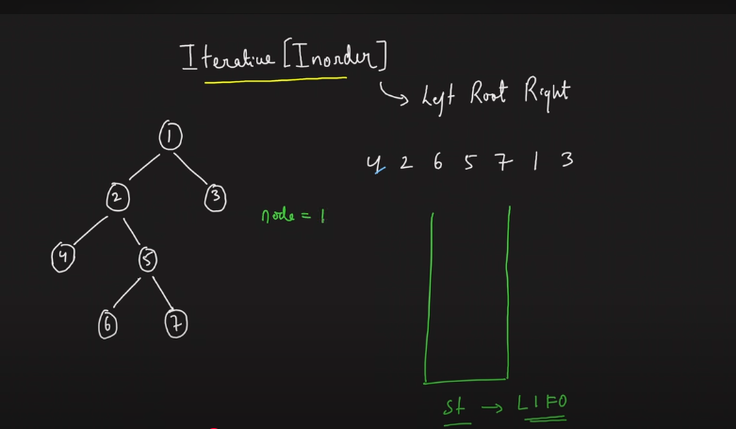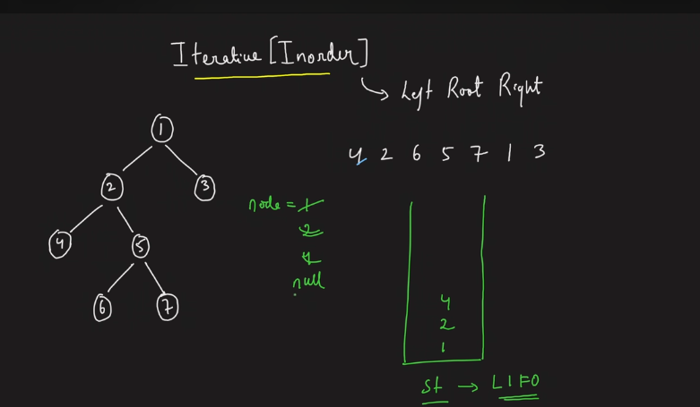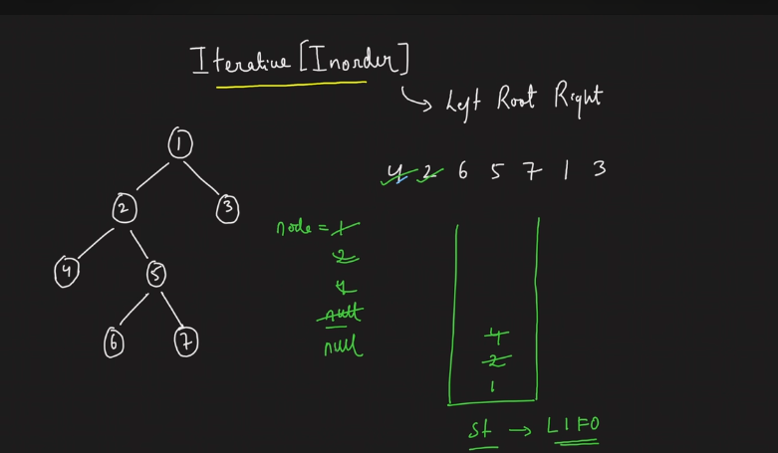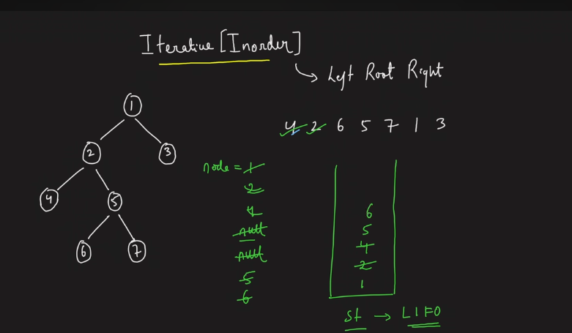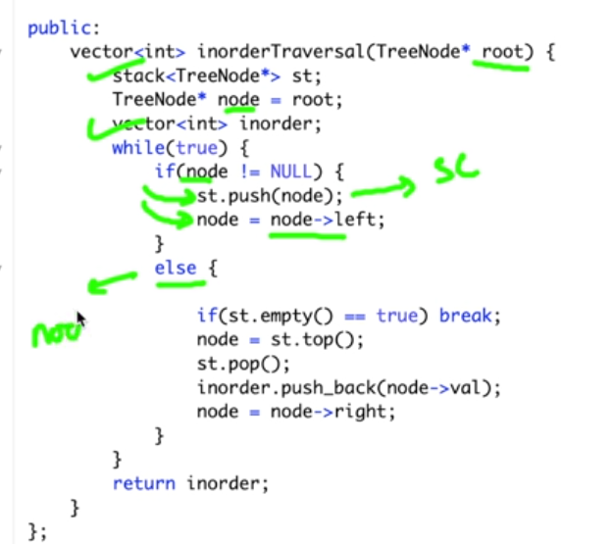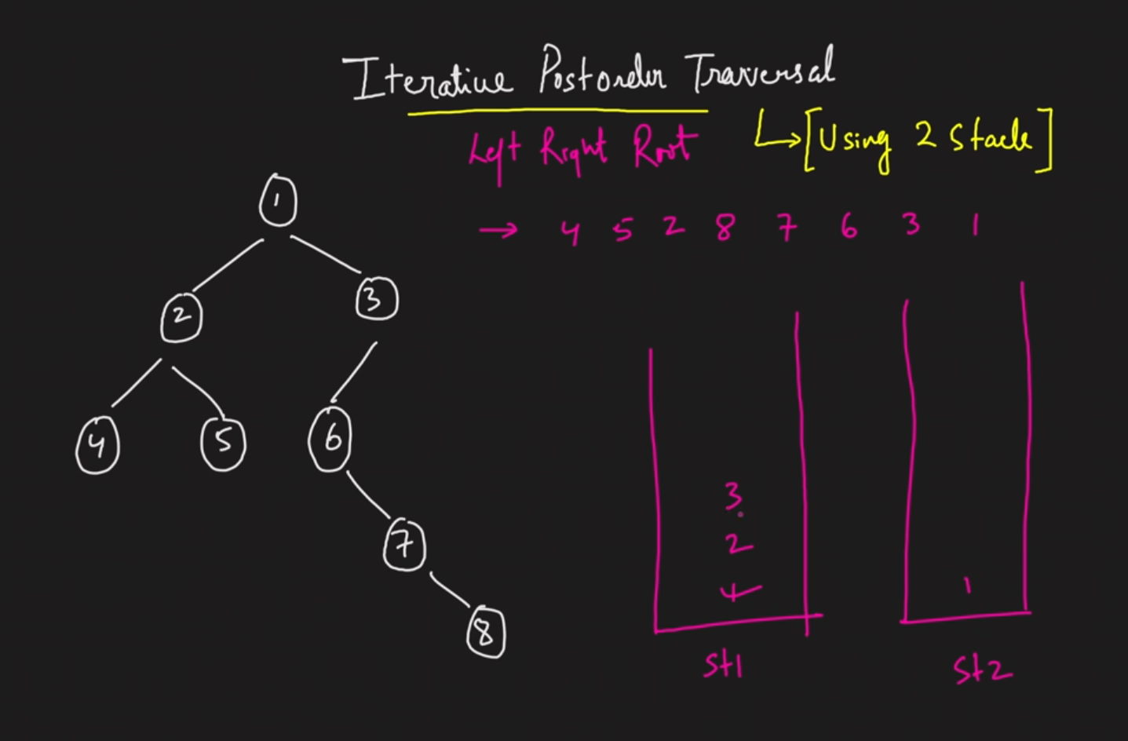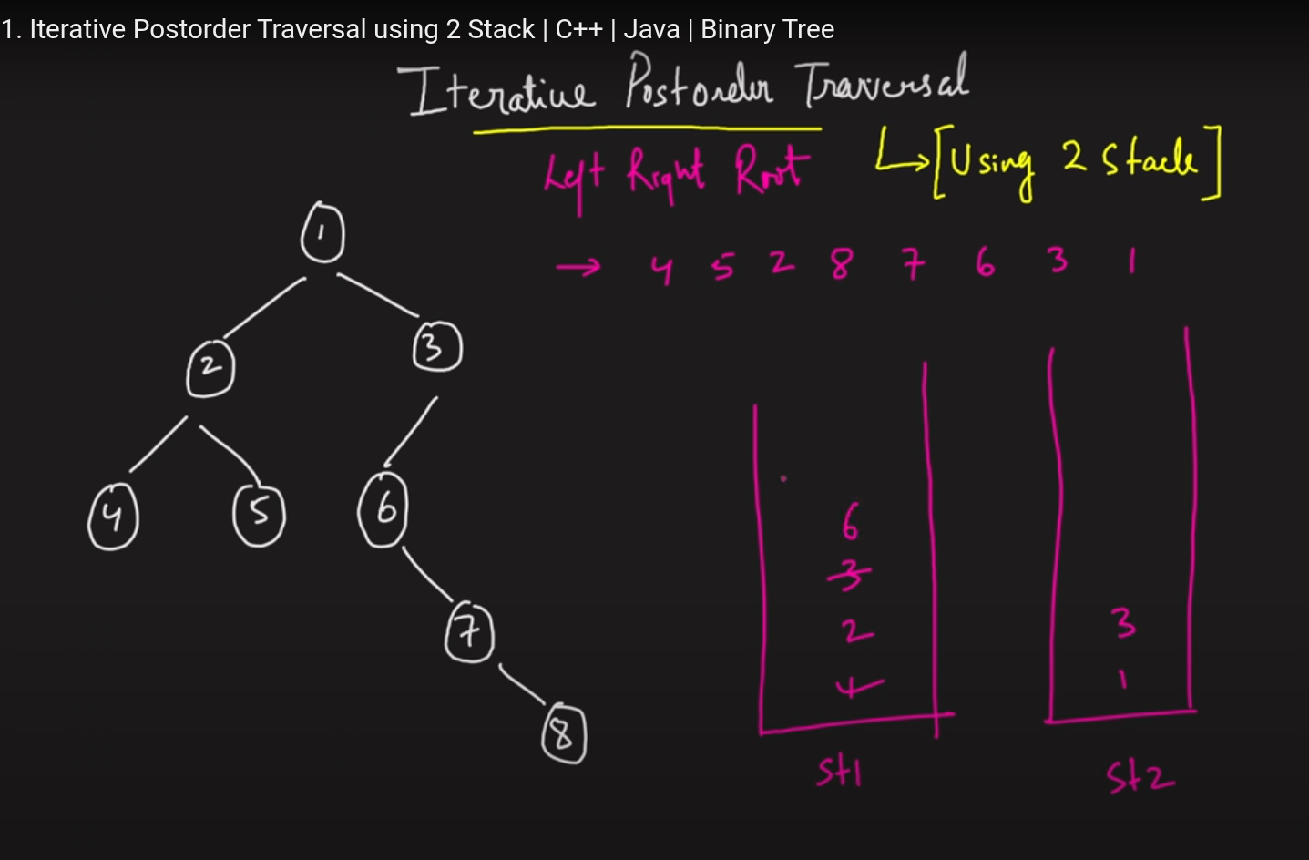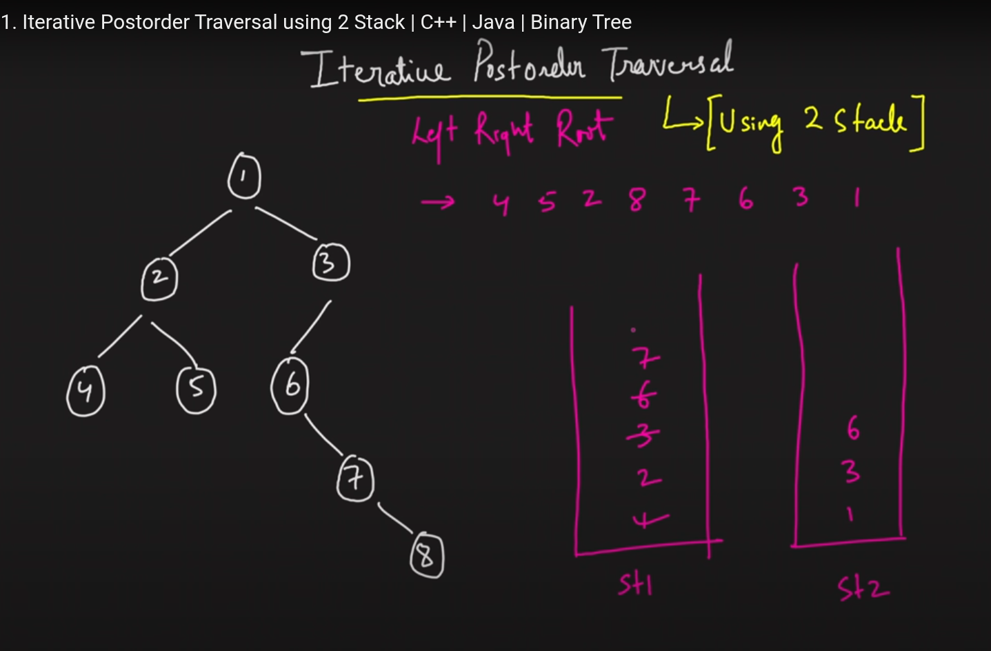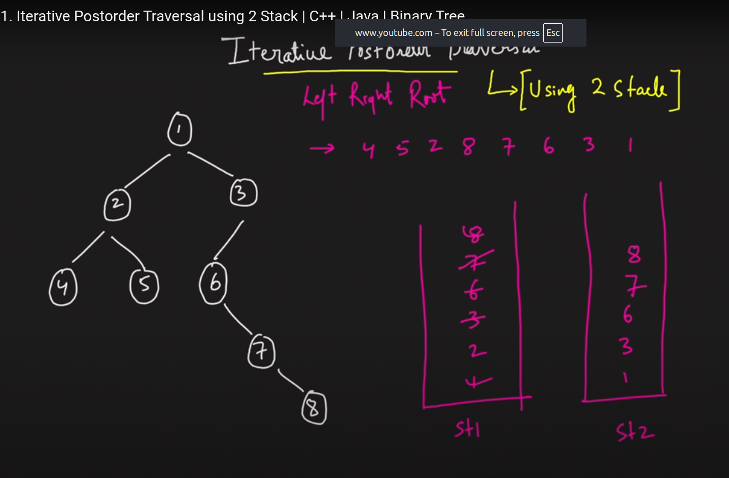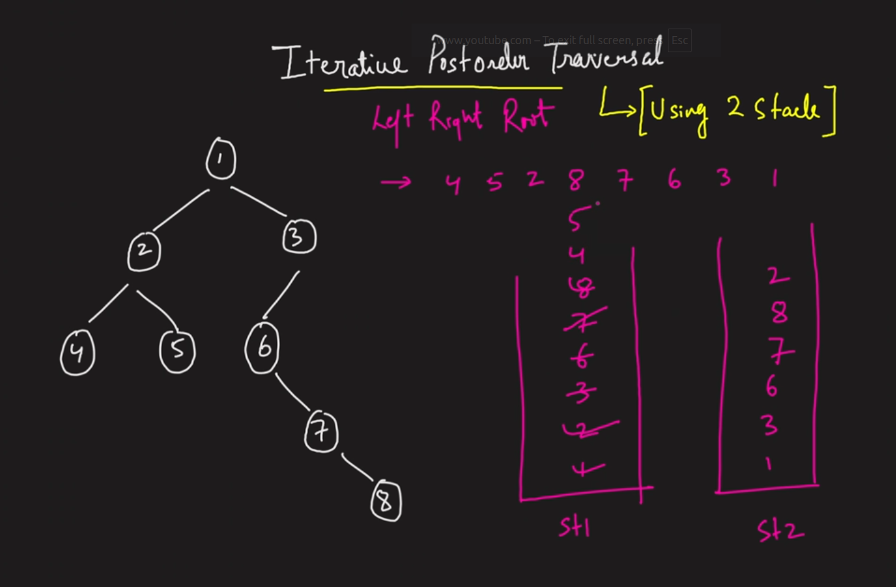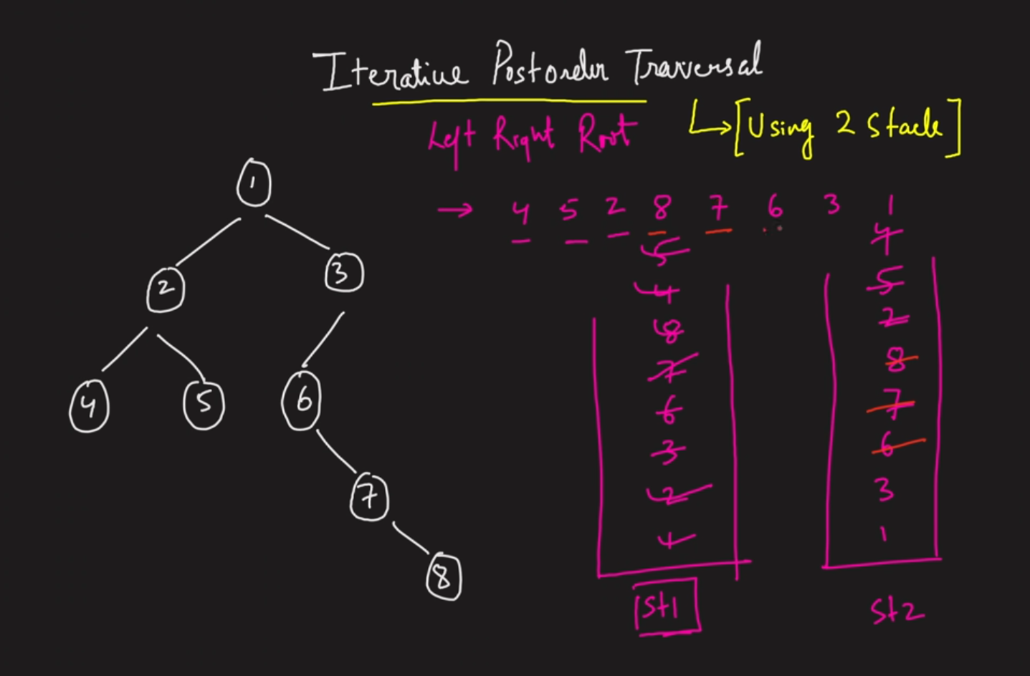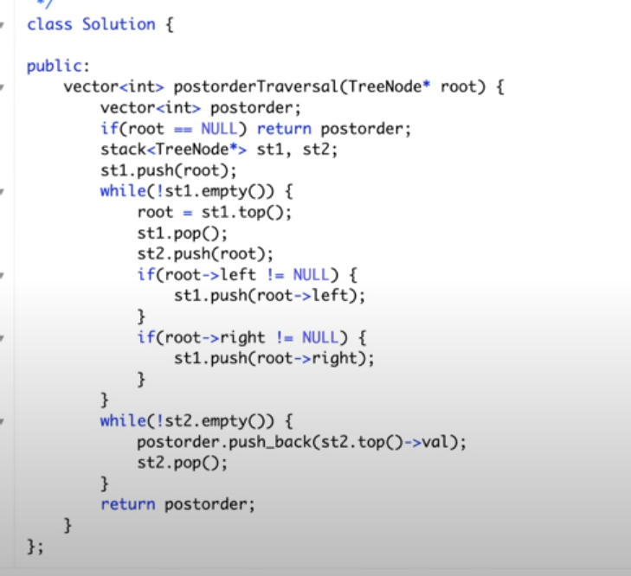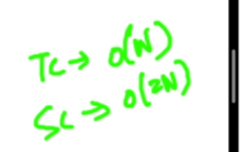

One stack implemntations.

**Print Root To Node Path**

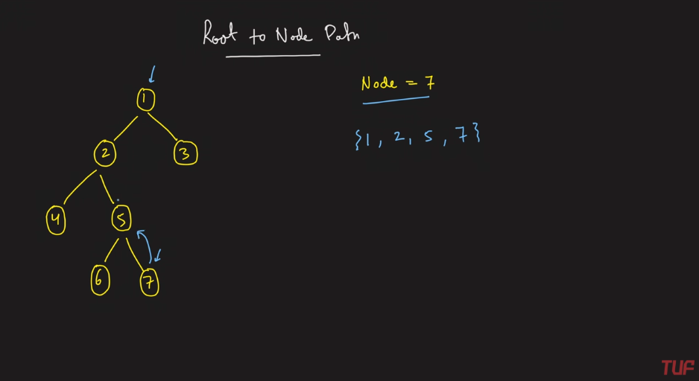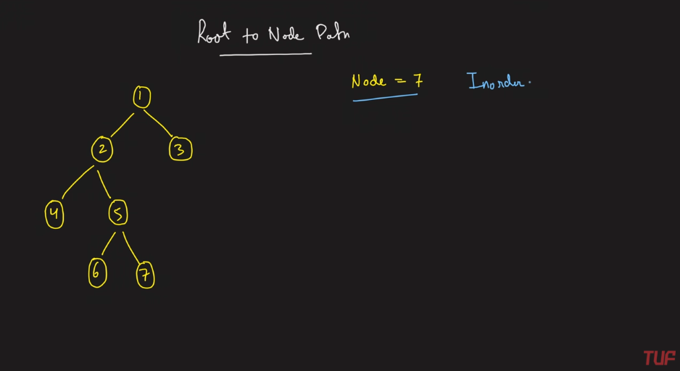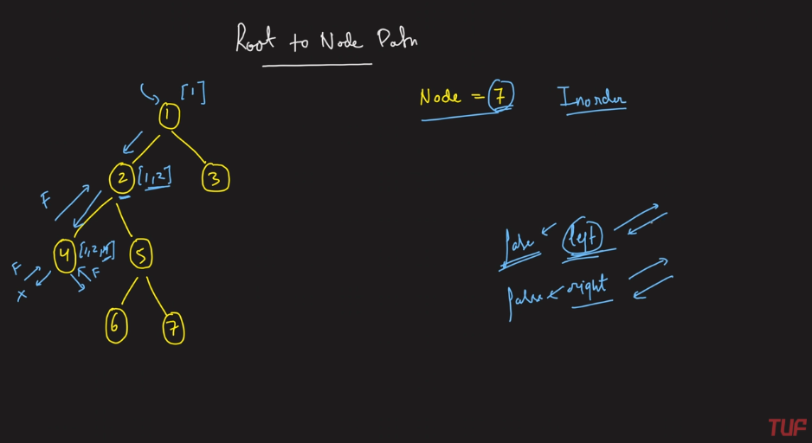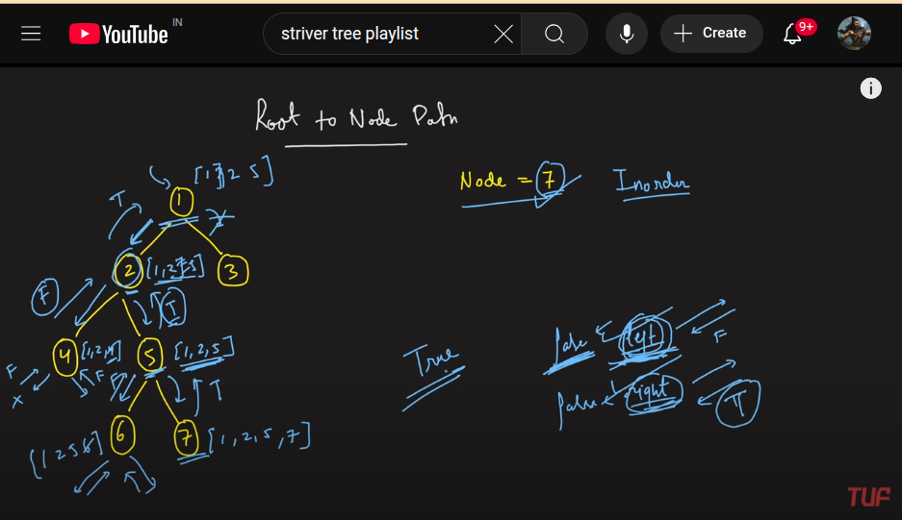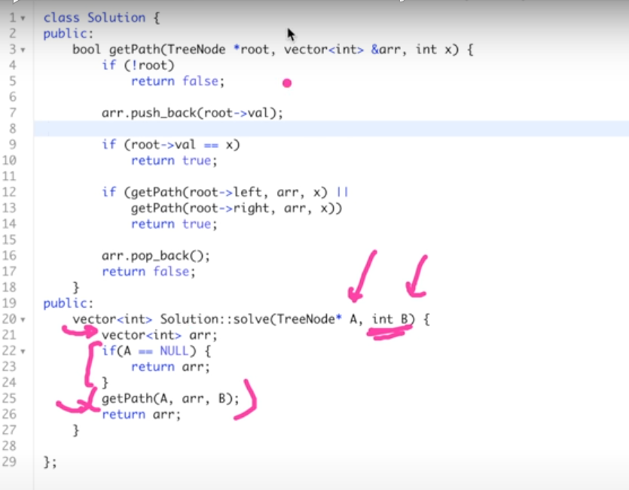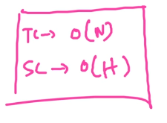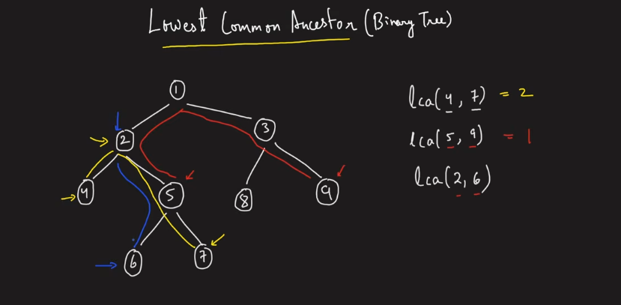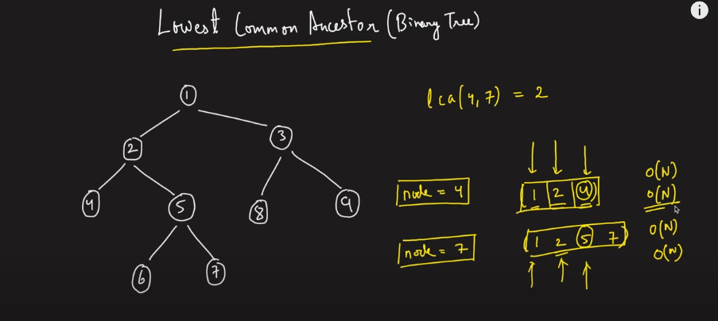

Above is the brute force; Find the path from root to the node. Then start comapring. The one which is having the common in both when we start to traverse, then the last equal is nothing but the common ancestor.

Need to optimise the above space complexity

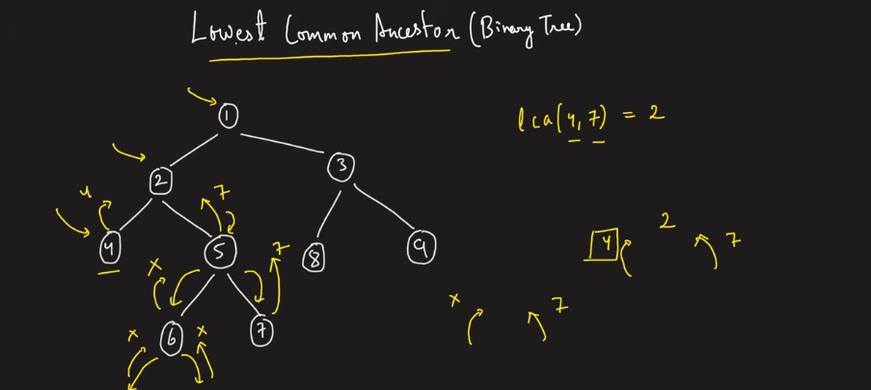

If both the right and left are not null then we can consider that to be as the common ancestor.

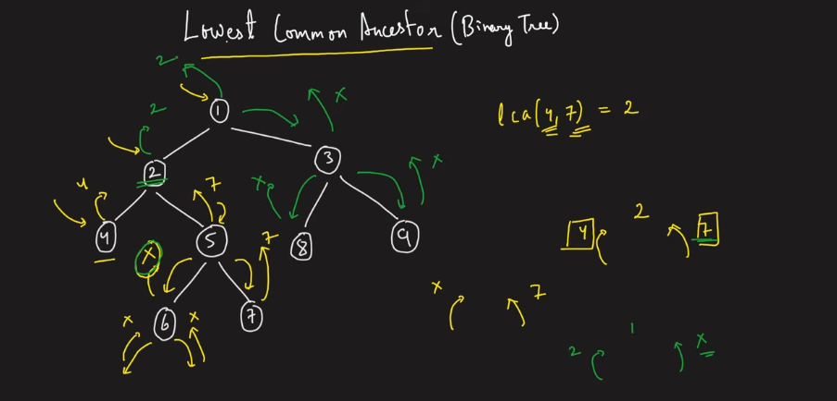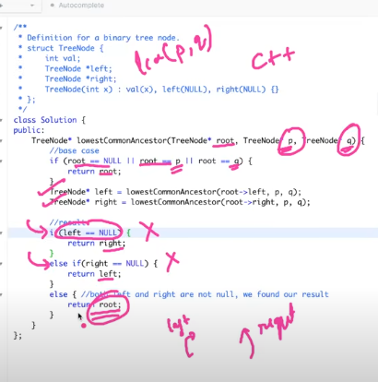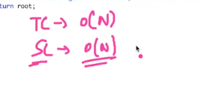

**MAXIMUM WIDTH OF A BINARY TREE**

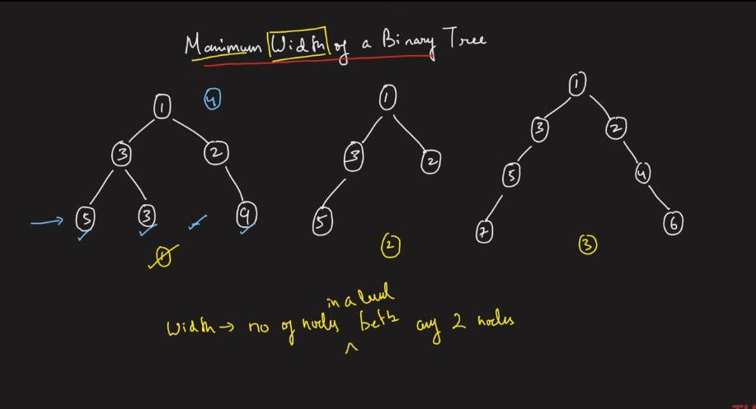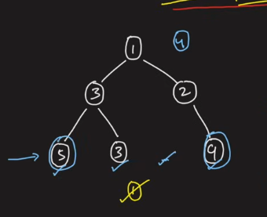

Between 5 and 9 which are in the same level the huber of nodes available is 4.

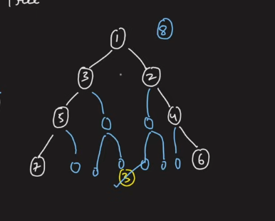

The nodes are arranged in such a way tha, if I’m going to inde them in such a way thtaa

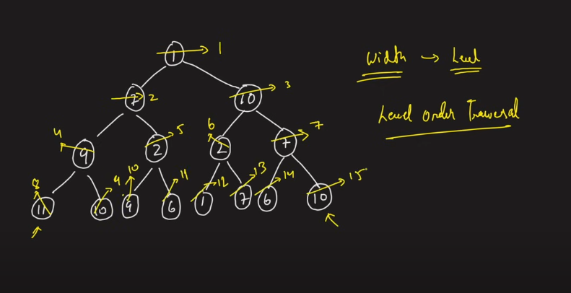

If indeed in this way, then pickpu the first node and pcik up the last node, and make the difference between those things, which are belong to the same level.

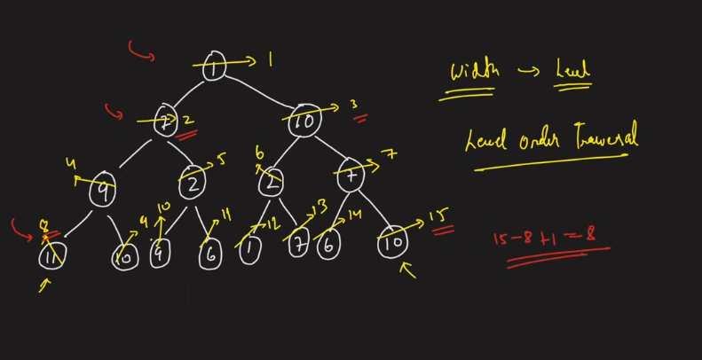

Even tough the nodes are not available, then we need to index in such a way that, it ha to look like elow to calculate the maximum width .

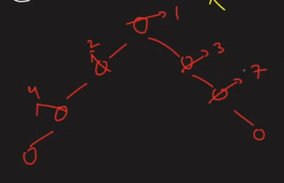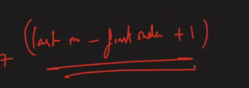

Indexng types

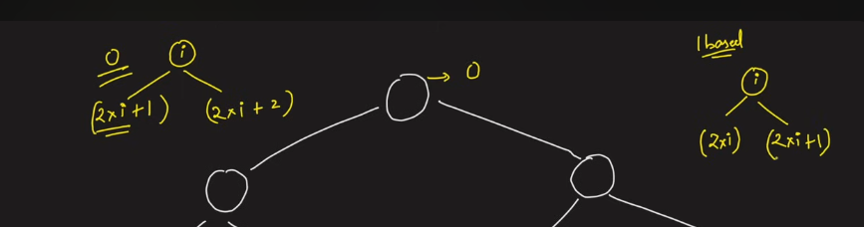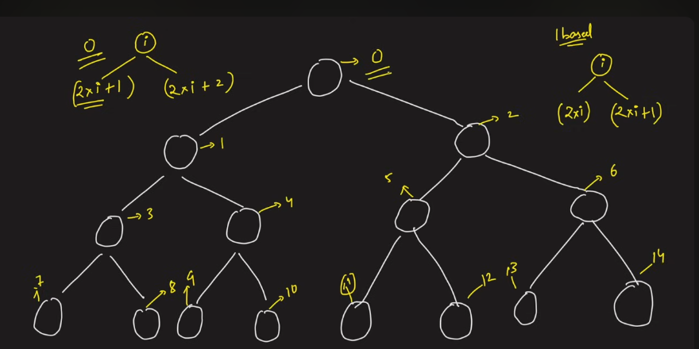

If the indexing is maintained, then every nodes will look like the above. It comes from the segment trees. Hnece even thouugh the intermeditae nodes are not there , it will work .

Failure of the above indexing formula: If it is like the below thene there will be overflow. Suppose we have to allot the trees in some ds, then the number of available nodes are less, but the array allotment is high, just to get the number of nodes the same level.

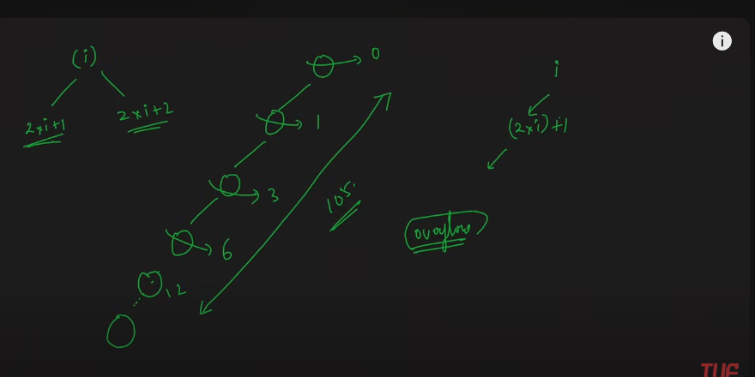

These things to be modified, to prevent overflow, the overflow in terms of the 10^5, to store this value, it can be overflow. Integer overflow.

Hence irrespective the number of nodes that are present overall, just givng the static indexes like the one which is getting started as a node in the level , starts with 0. The ending shall be n-1.

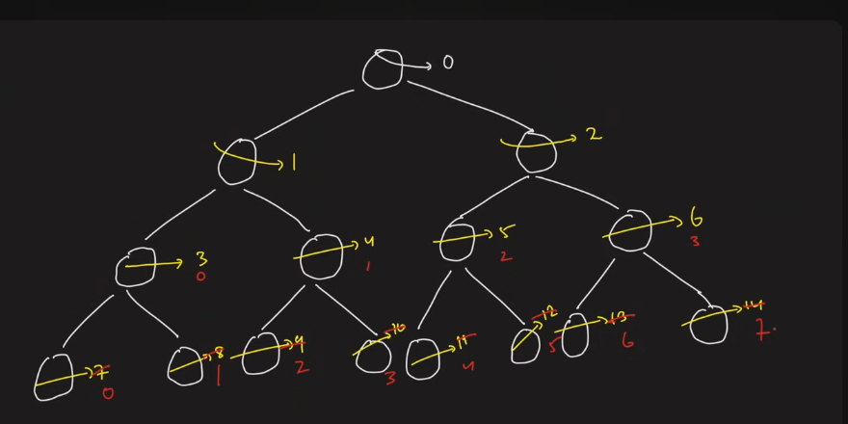

**Trick**: Subtract 1 from every nodes parent and then apply for the 2*i+1 formula. Hence we can achive the correct format. Hence this will not give the overflow effect.   
Overflow:

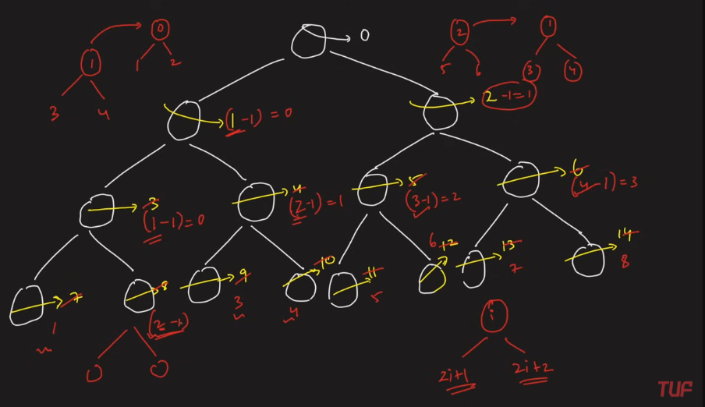

Below is the preocedure

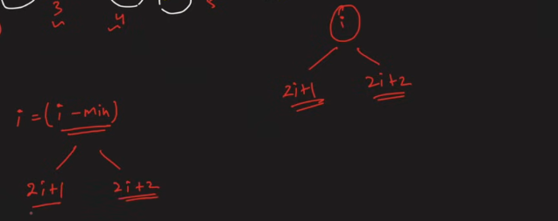

Min is the starting ones’ second

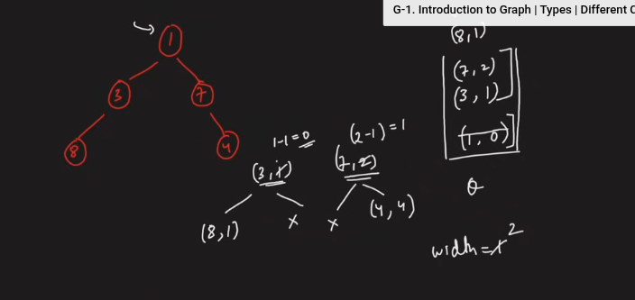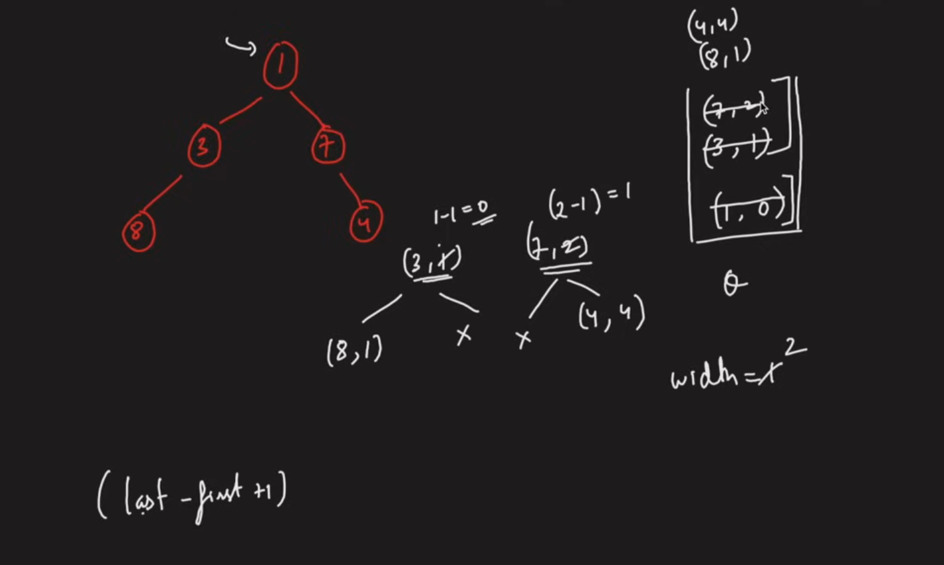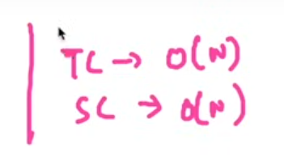

**Children Sum Property in Binary Tree**

Given binary tree, each node with some values in it.

**Node = left + right**

If the above thing are not followed, then we need to add 1 to each and every node,so that the above will be followed.

You can increment the right value or left node value, but condition should follow.

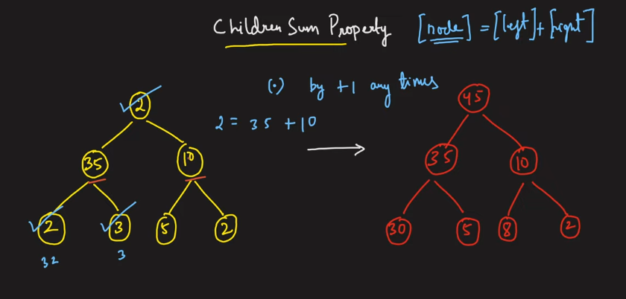

Below is one challenge.

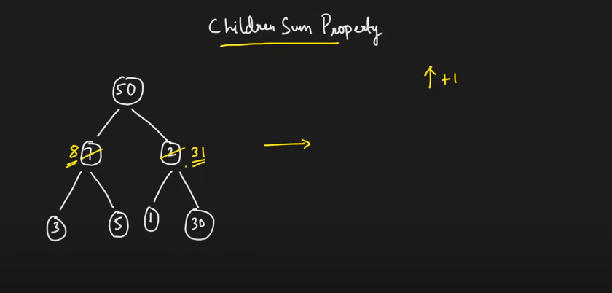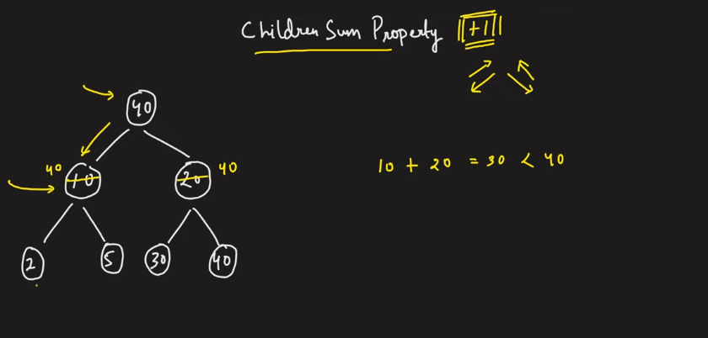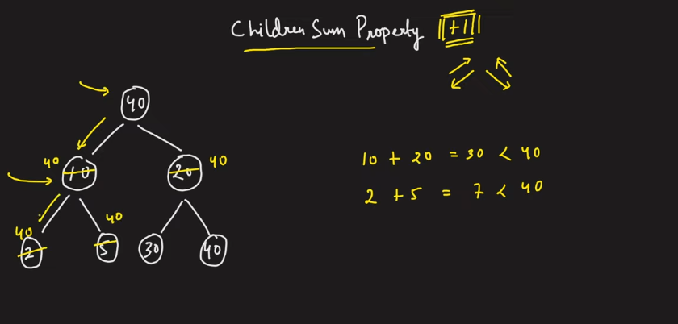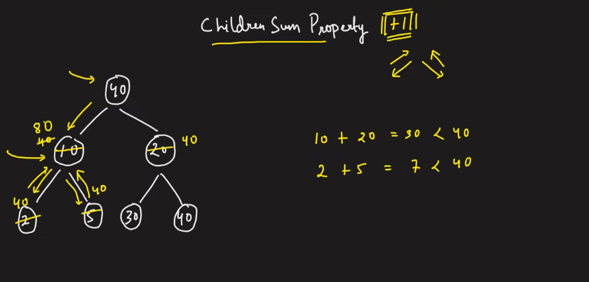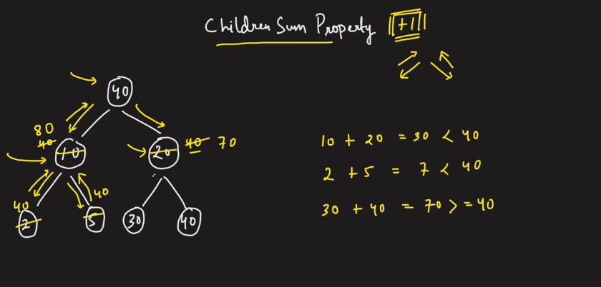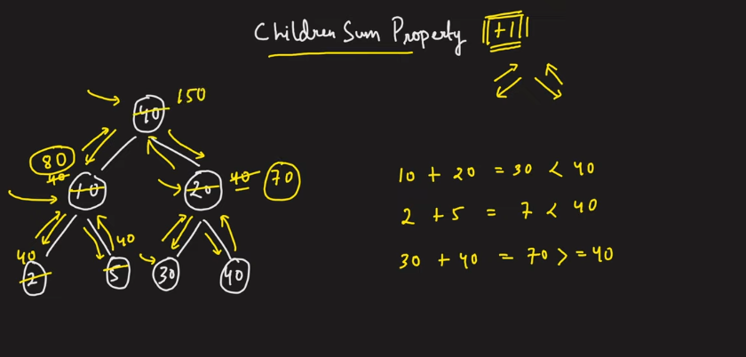

The below did not work, because we fell shorter by all chances wiht their originl value, so we need to make the vaue of the children shall be equal to the parent and while coming back we can change the root value by increasing but the decrement will never work.

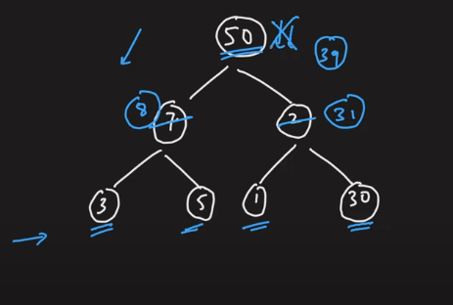

The below is going to guarantee, that it is going give the children sum property. Hence we never follow the short of numbers.

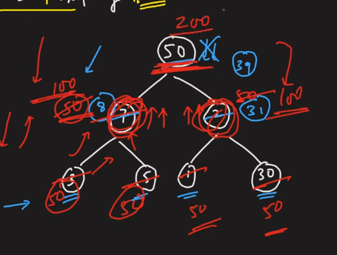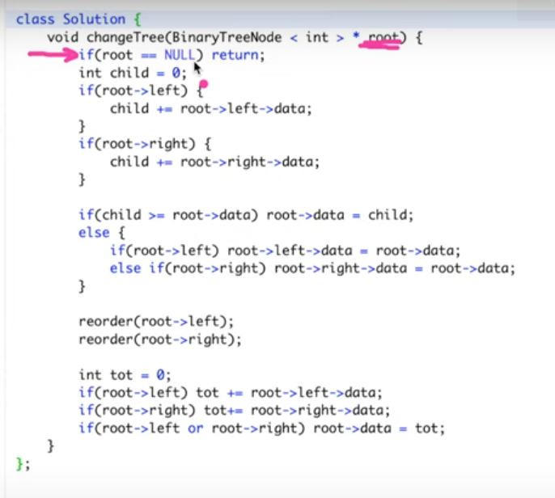

**NODES AT A DISTANCE K**

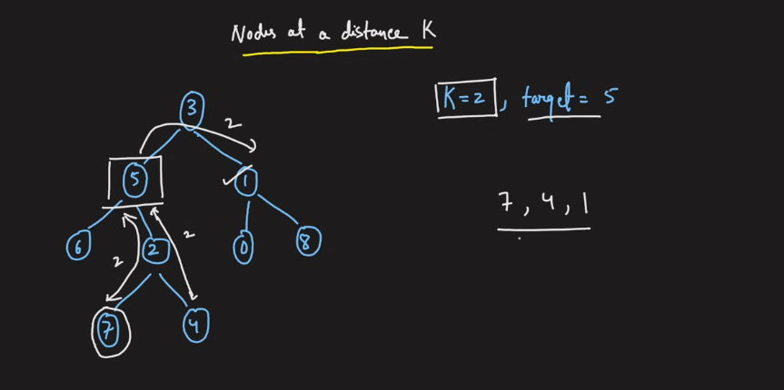

The problem with this kind of tree is that, the nodes which are at some distance from the node to its chidren can be traversed, but from node towards the ancestor.

BFS traversal to eratdicate the above problem.

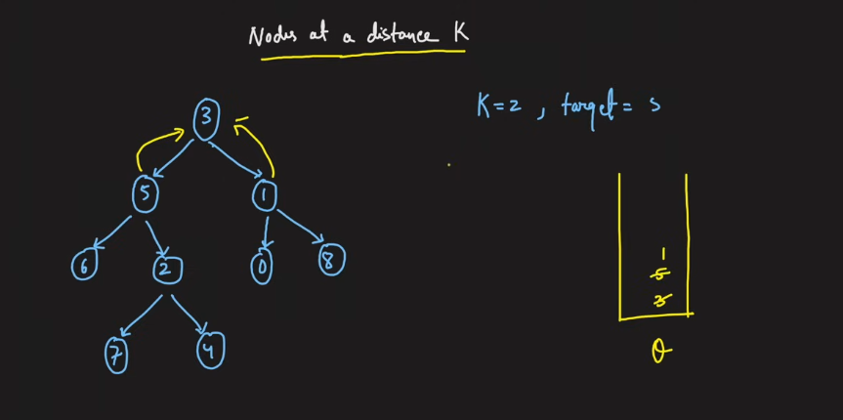

The blue colored edges are given by default and the yellow colored ones are the one intiated by the node and it is having and the path to the parent is stored somewhere in the map/hashmap.

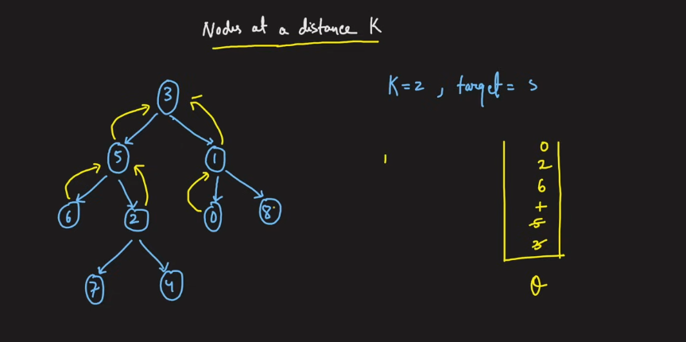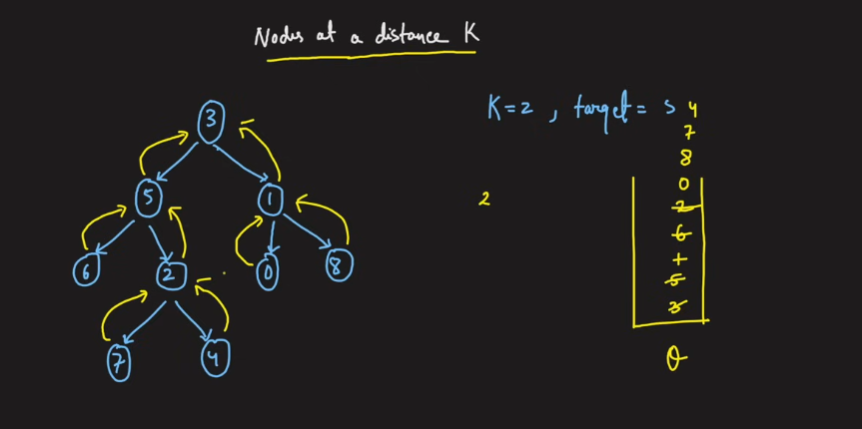

After this preperation we are ready to move for the distance traversal.

Use the dfs to traverse properly.

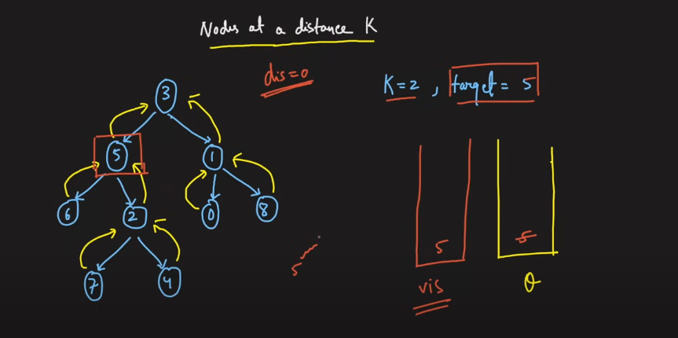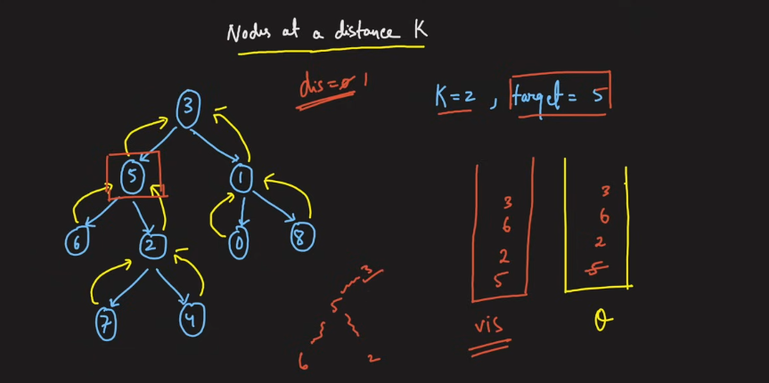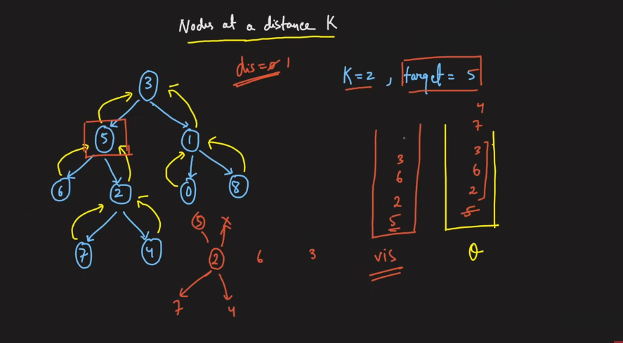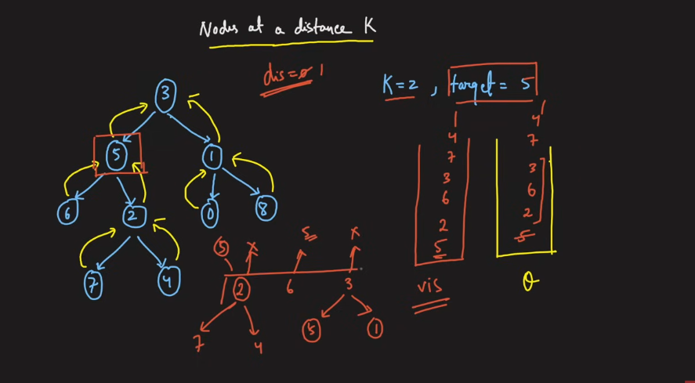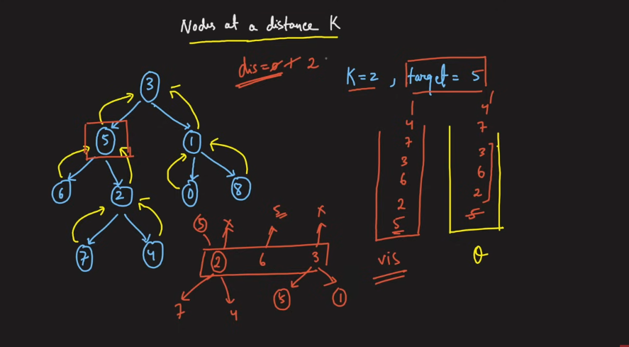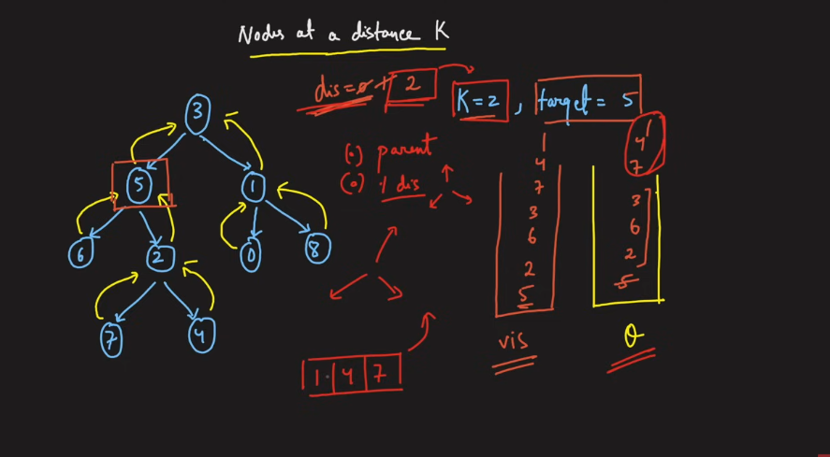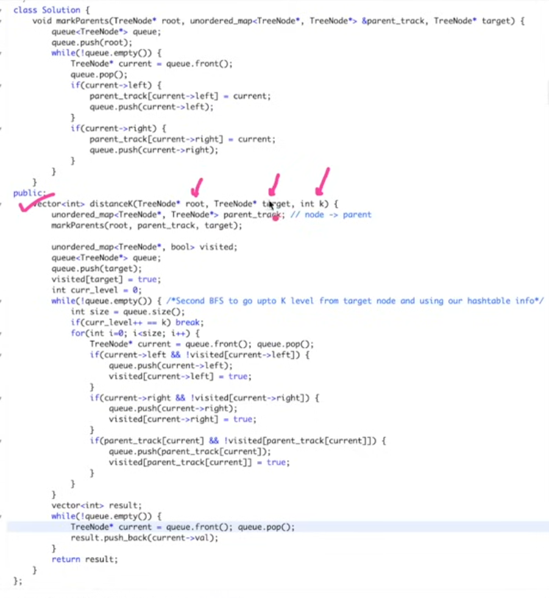

hash map +O(logn)

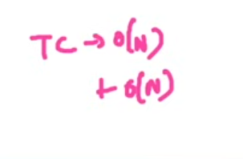

**MINIMUM TIME TO BURN THE TREE from any given node**

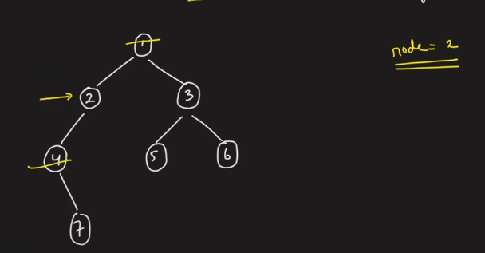

2 node takes one second to burn the marked in one second, 2 second fo the below.

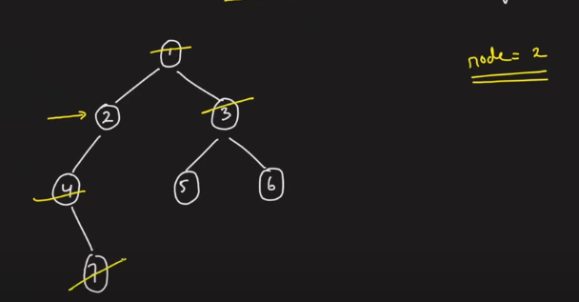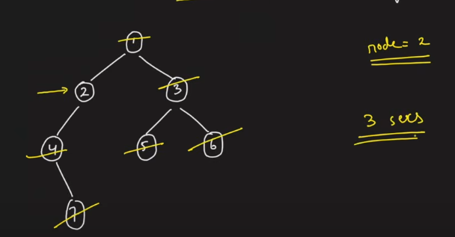

1. The pointers cannot move in radial fashion.
2. So create the paren pointers first.

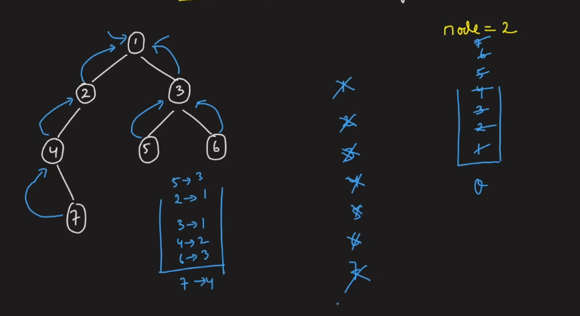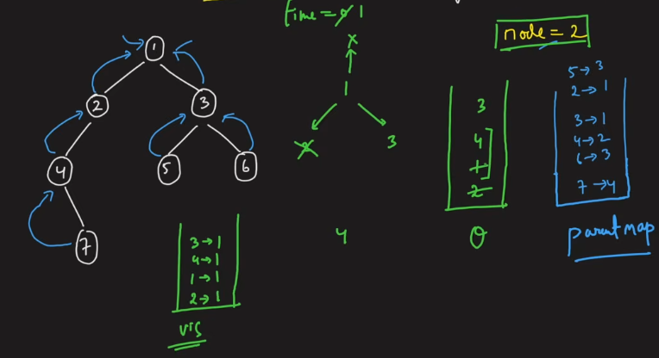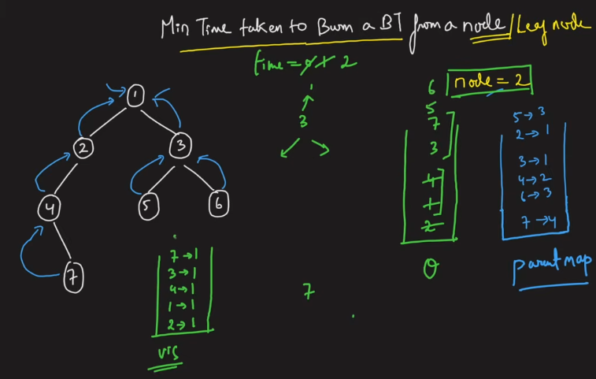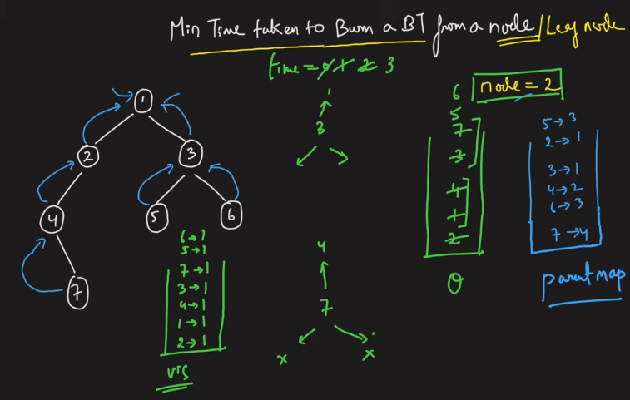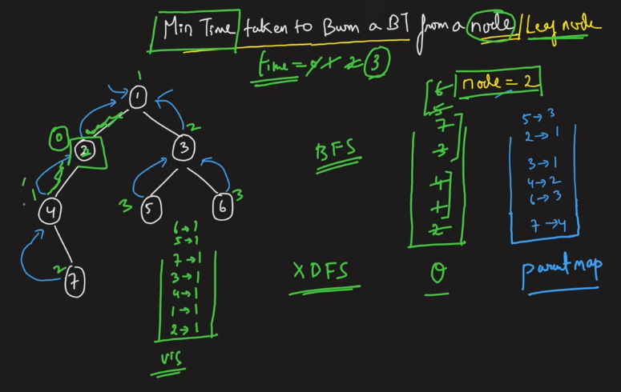

BFS is agreed, becuse the nodes which are a the same level will burn the nodes which are at the same level at the same time, hnec it has davnatage over the other.

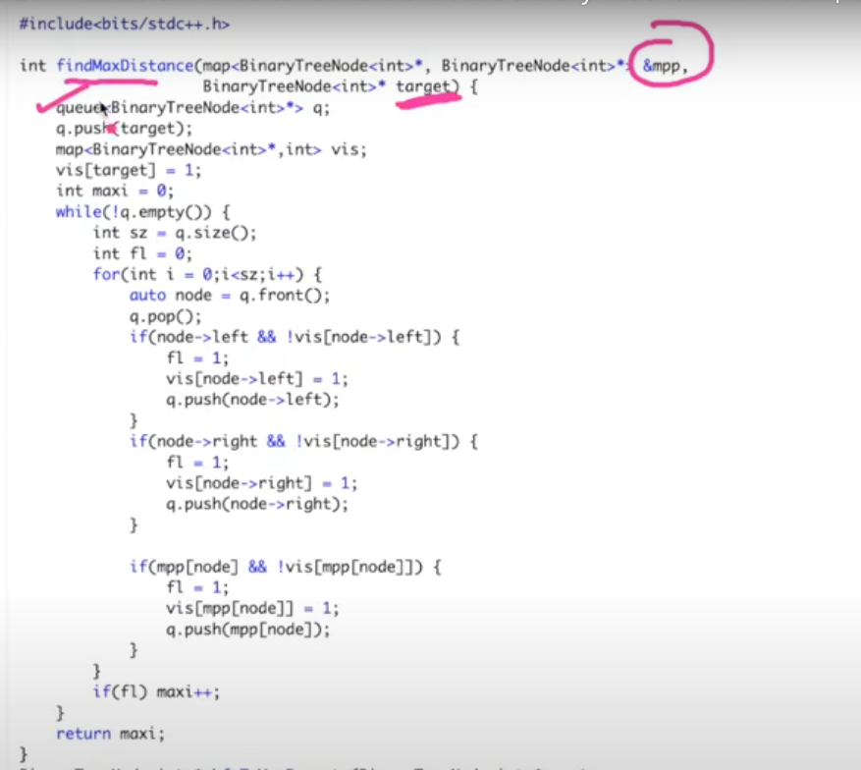

Burning is given by flag=1.

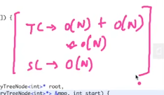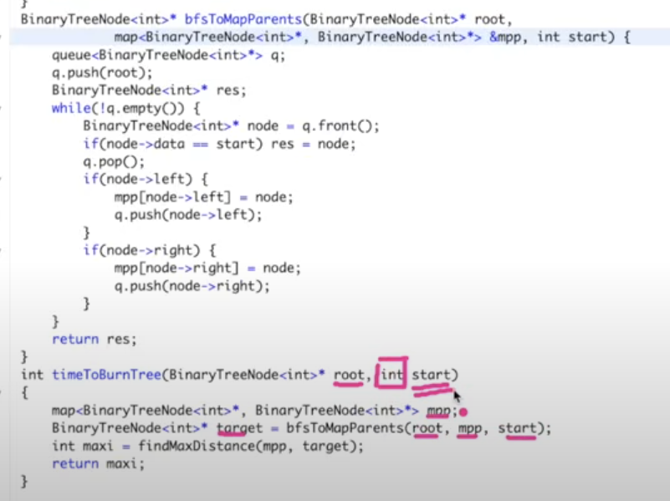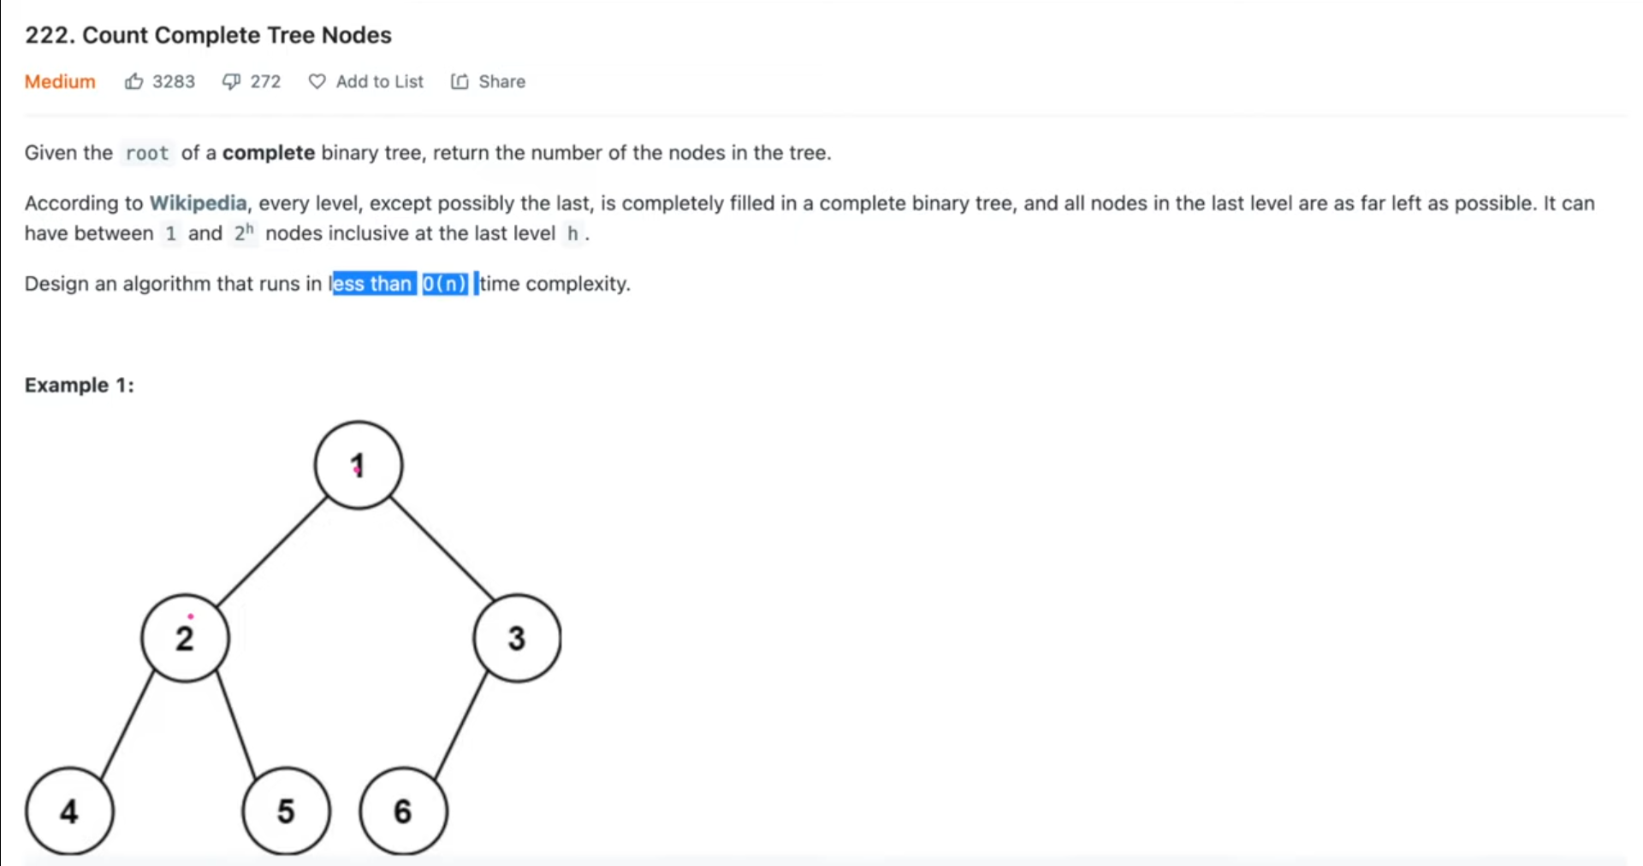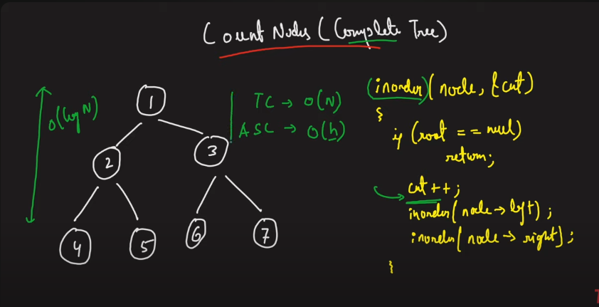

This time complexity is the issue. Hence we need to optimise this.

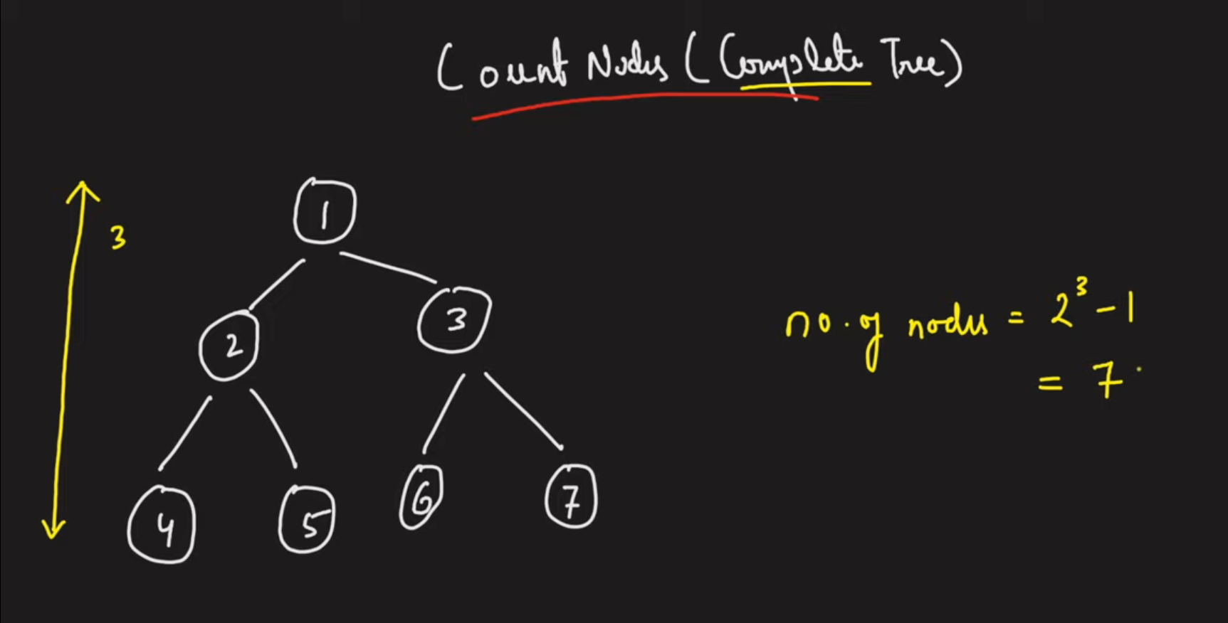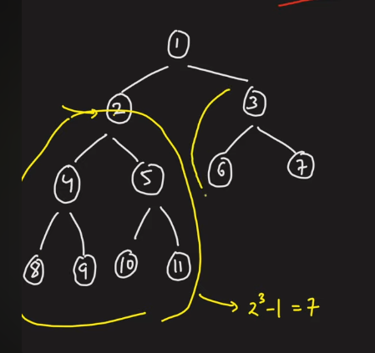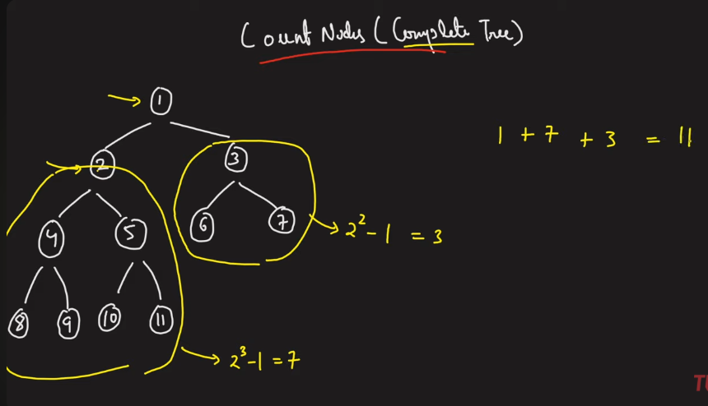

If any subtree is full binary tree, instead of ging to each and every node, go to a subtree and if that subtree is full binary tree, then use the formula.

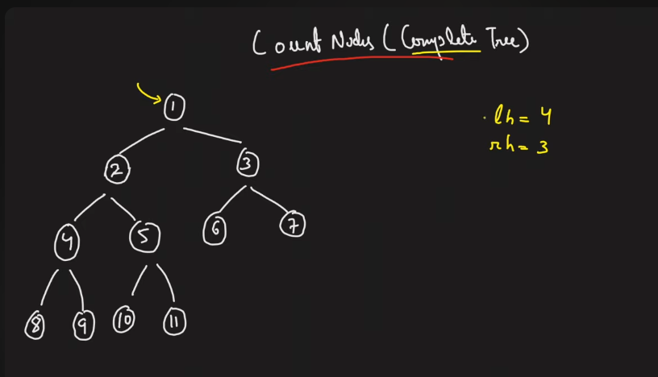

In the above lh!=rh, so it is not the full bt.

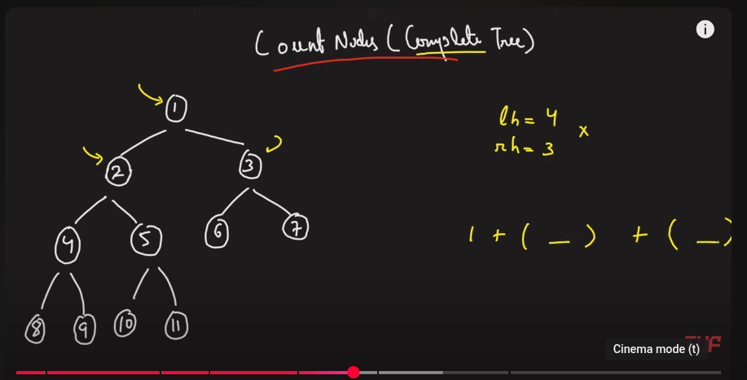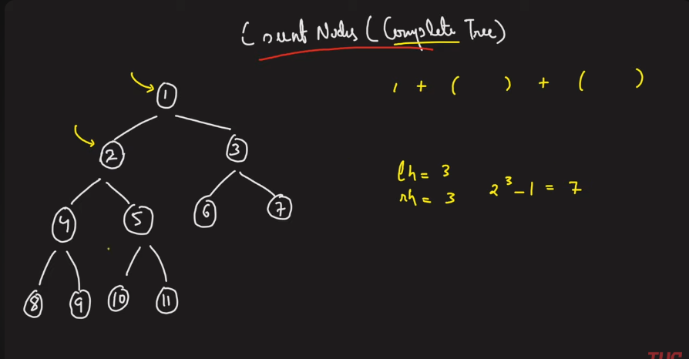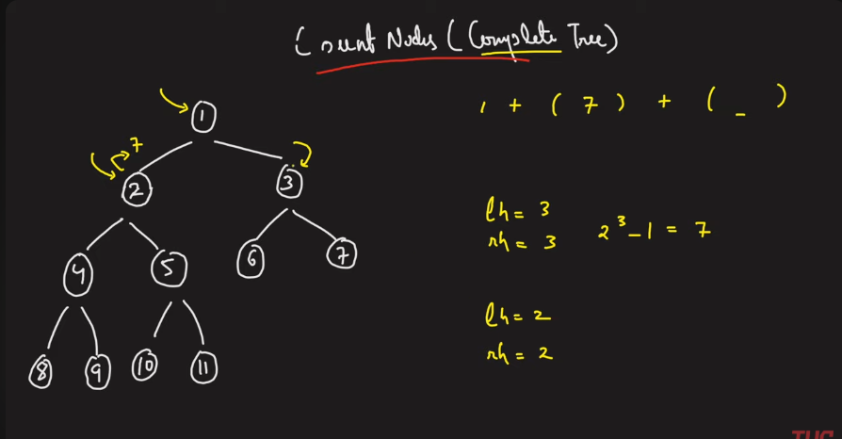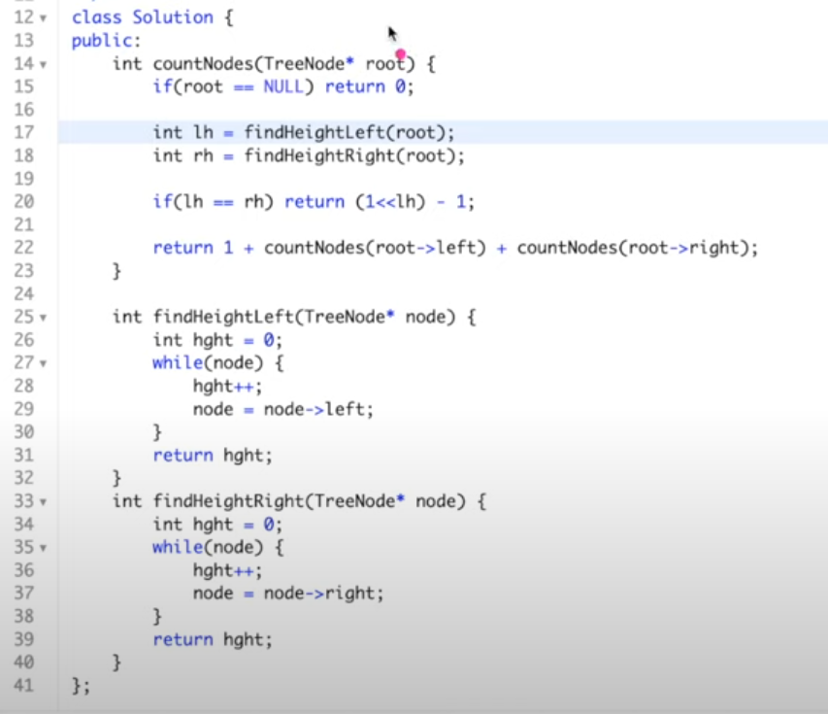

**Requirements needed to construct a Unique Binary Tree**

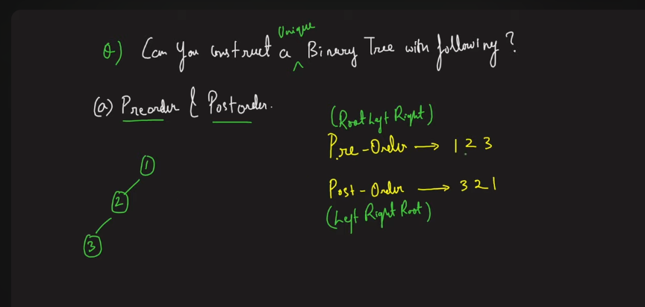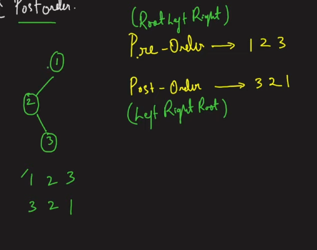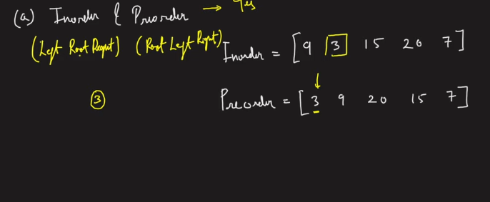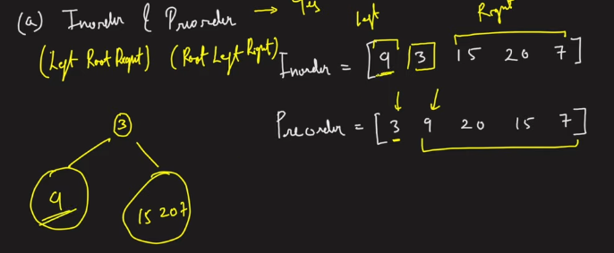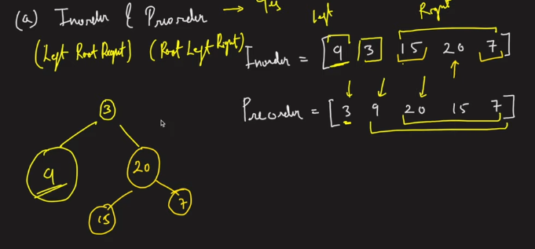

**CONSTRUCT BINARY TREE RFOM INORDER AND PREORDER**

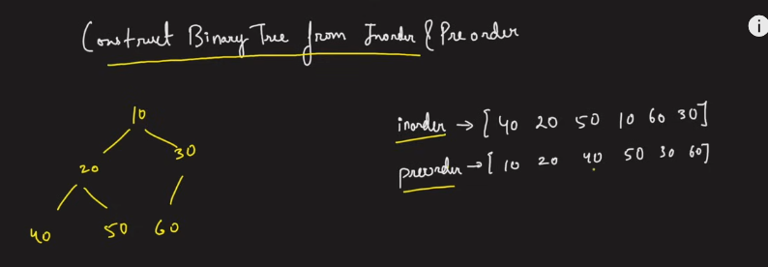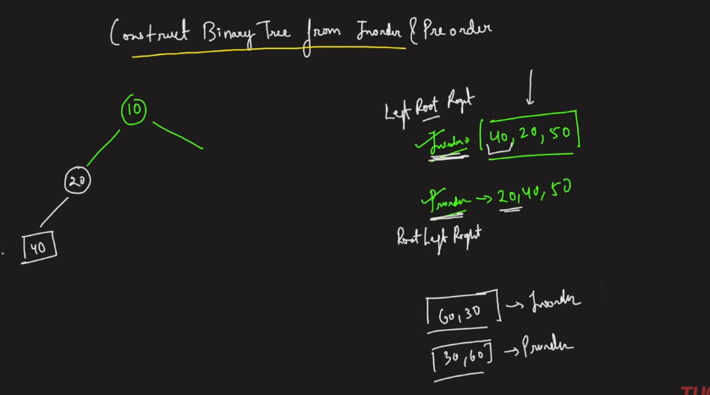

Coding the above:

1. The values in the inorder array shall be hashed.

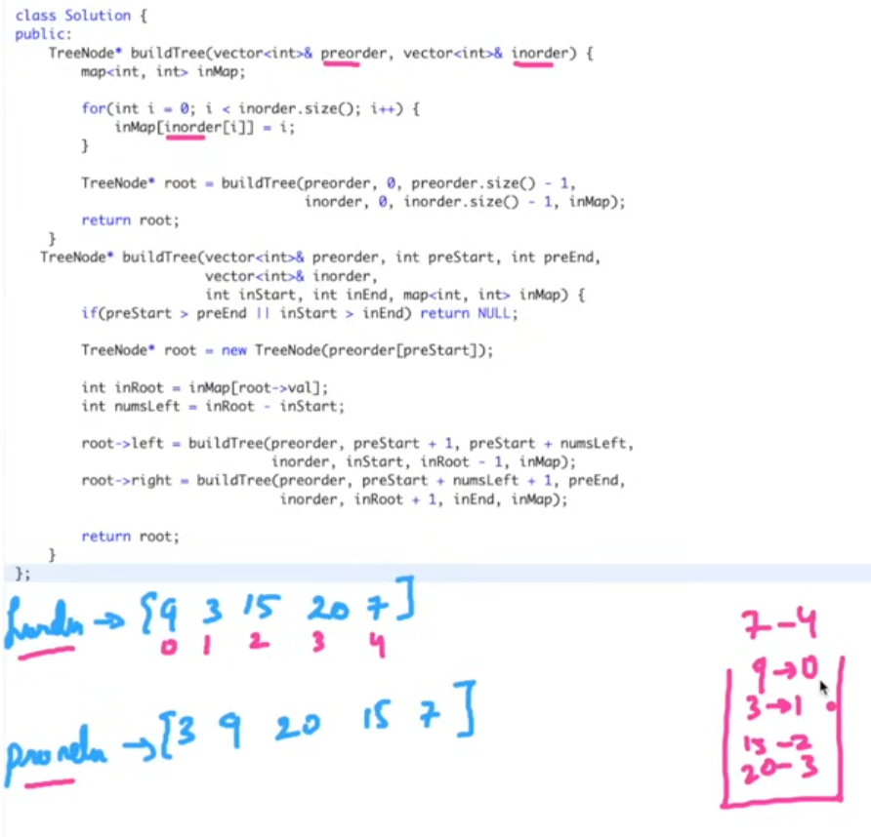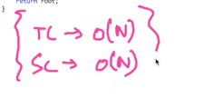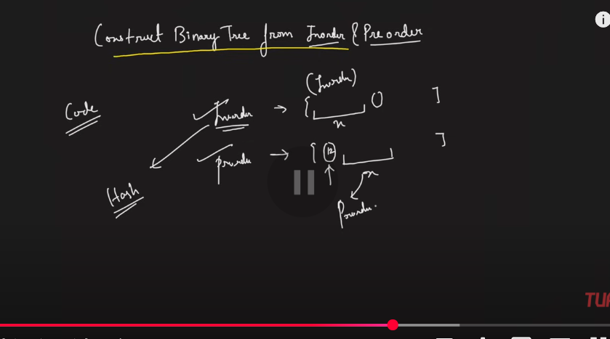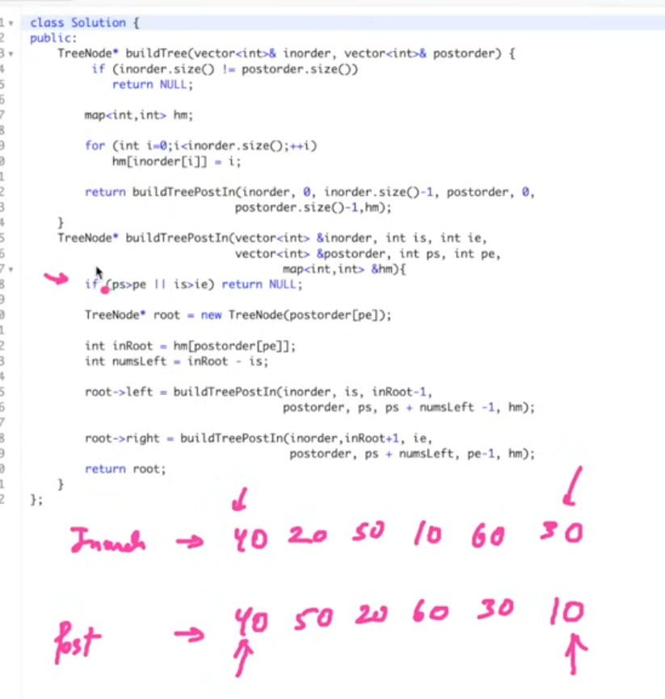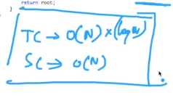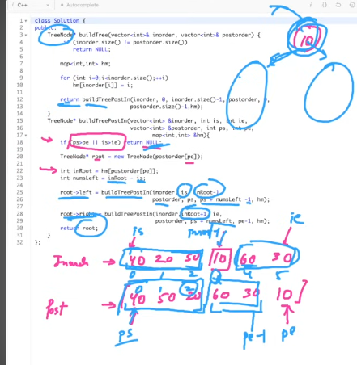

**SERIALISE AND DESERIALISE BINARY TRE**E

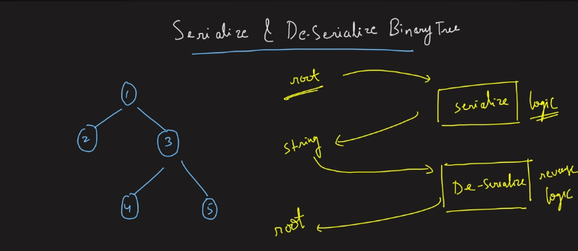

You can follow any order.

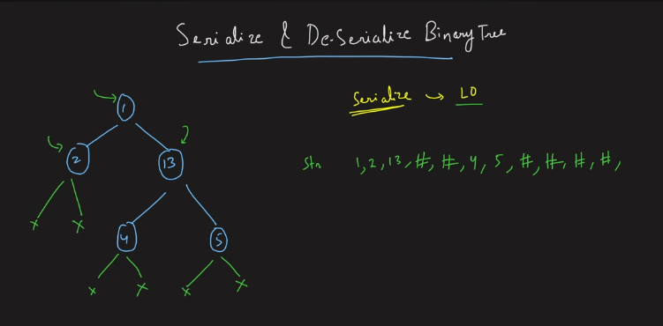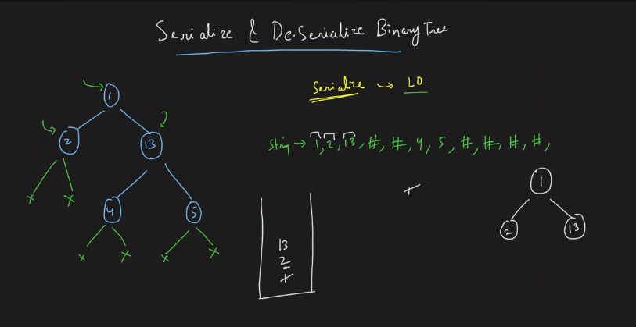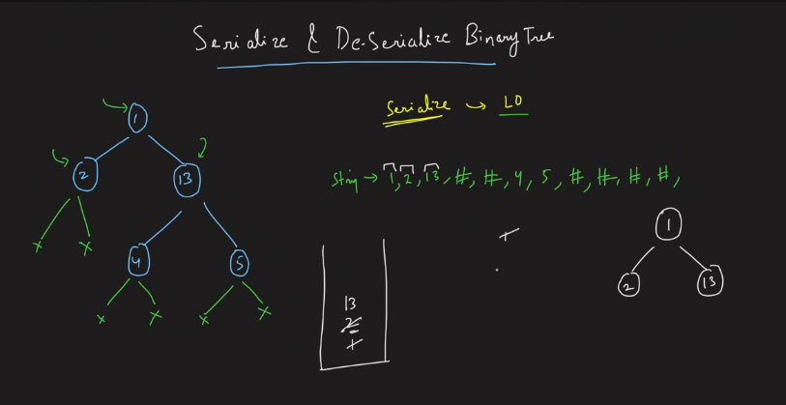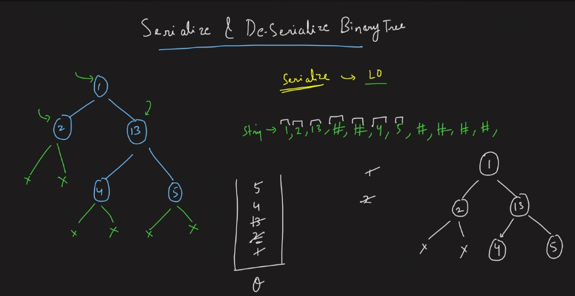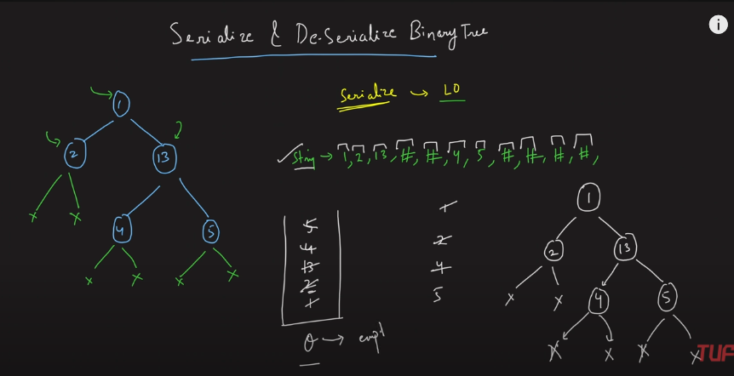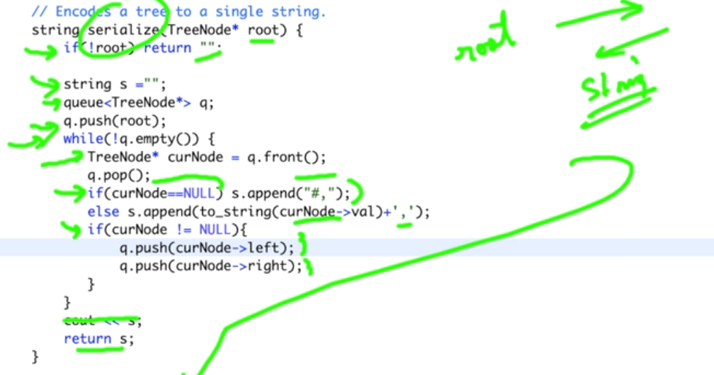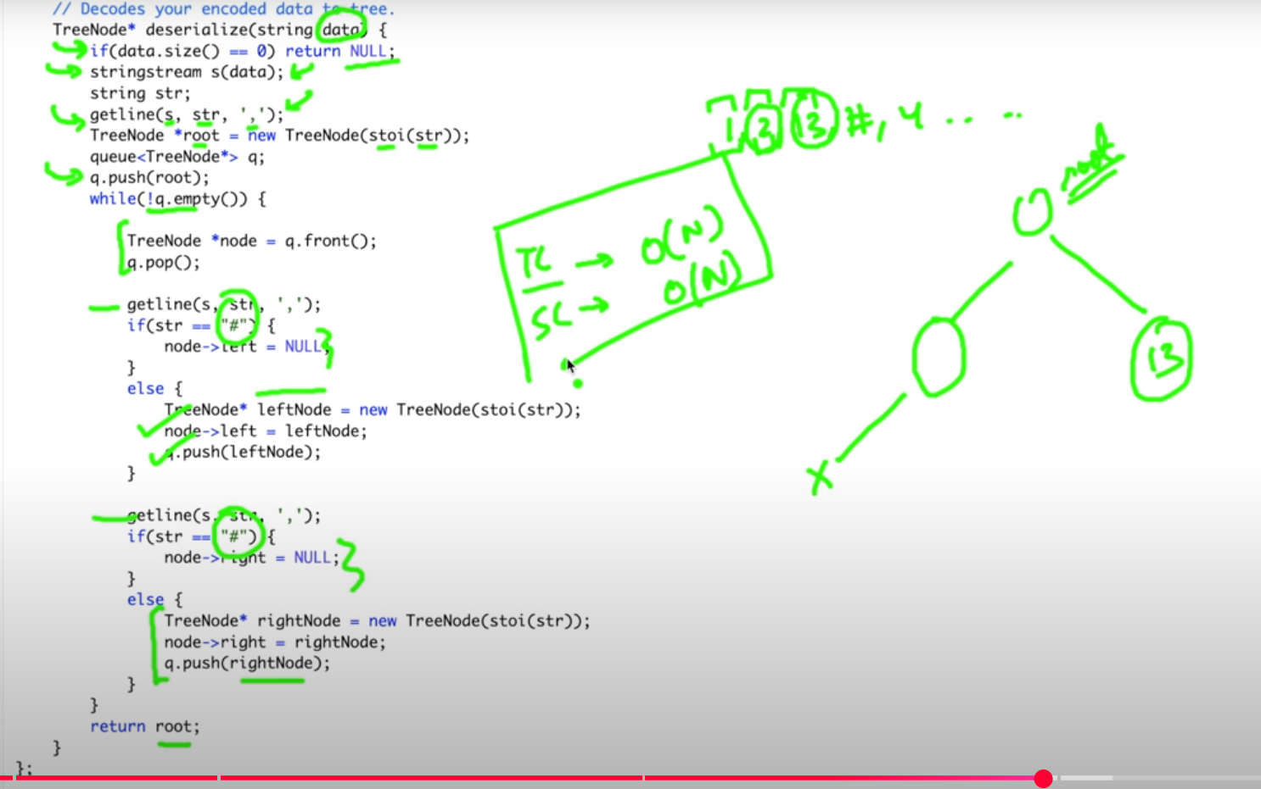

**MORRIS TRAVERSAL**

MORRIS: TC – O(N), SC –O(1)

NORMAL TRAVERSAL : TC – O(N), SC –O(N)

Because this morris traversal uses the threaded binary tree

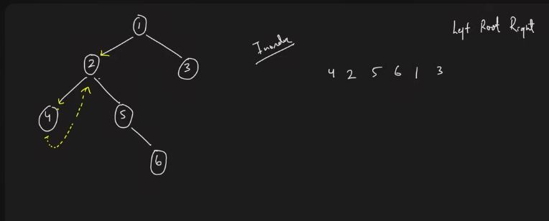

The dotted is backward pointer.

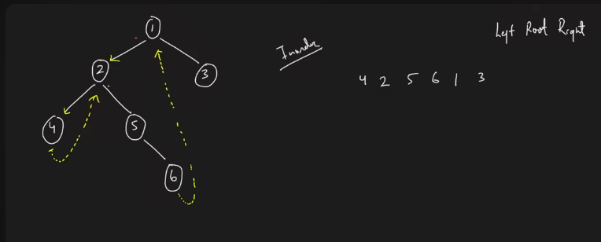

So, in the above if the threaded binary tree is used, then it will not traverse in the backpropagation way, that is after 6 it will not backtarck to 5,4 etc. But if you use this, it is going to travel in the from 6 to direct 1. Which reduces some traversing on nodes.

**Observation**:

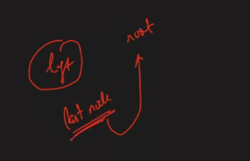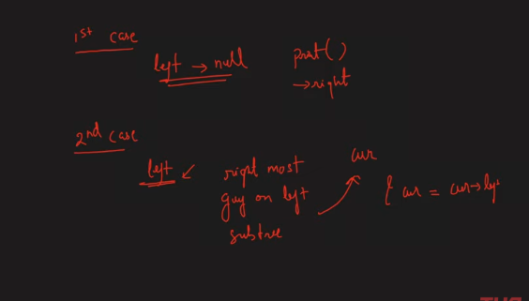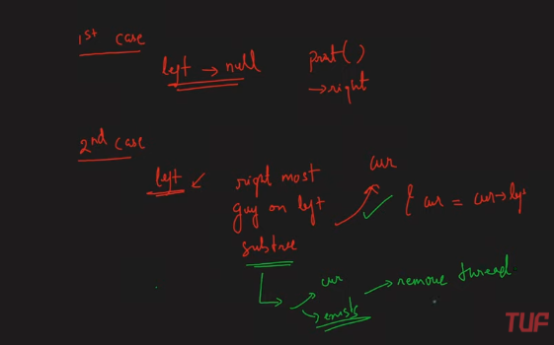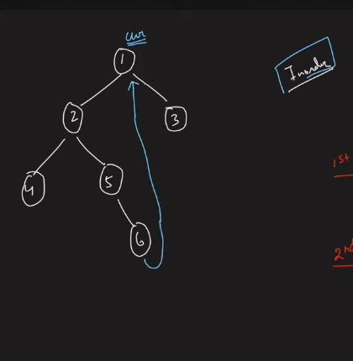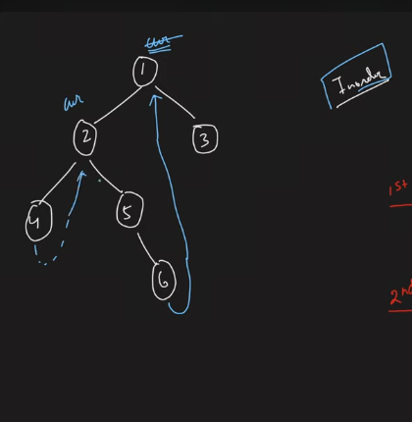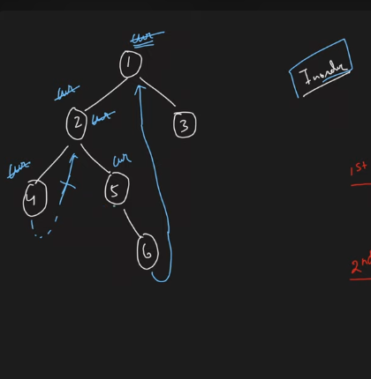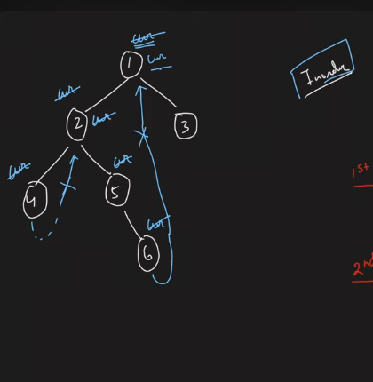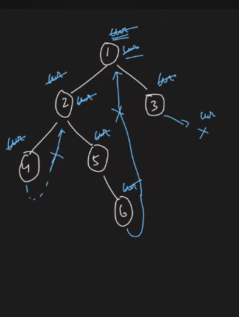

**Segment trees**

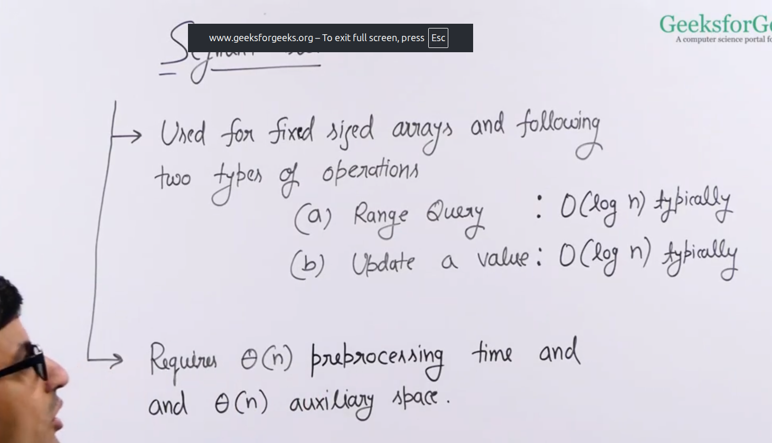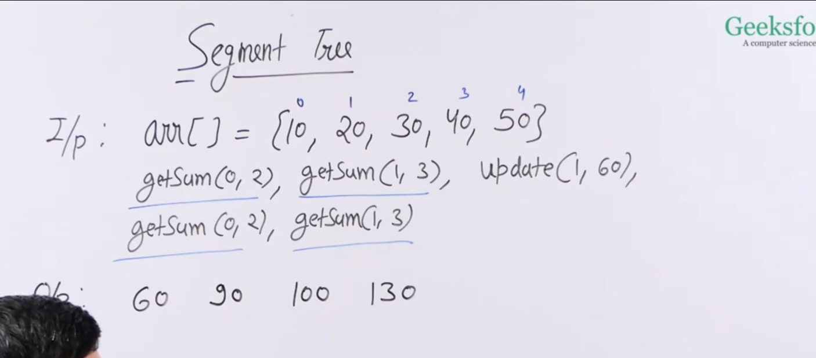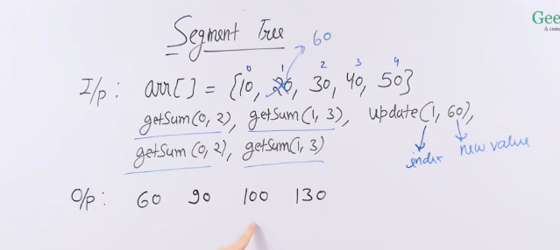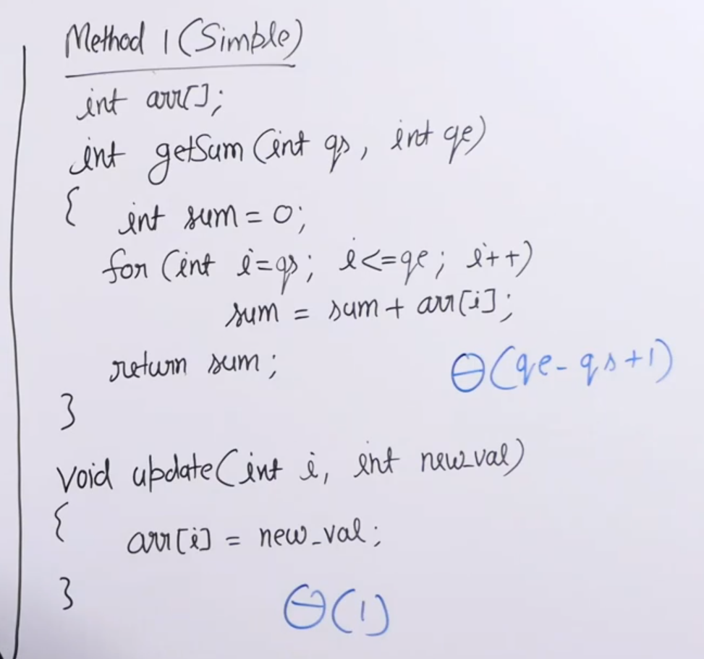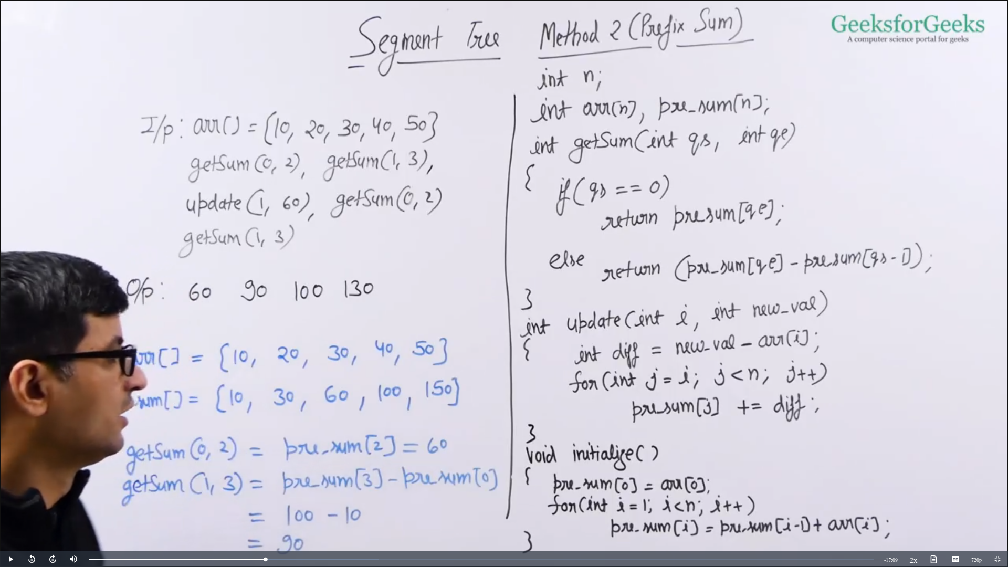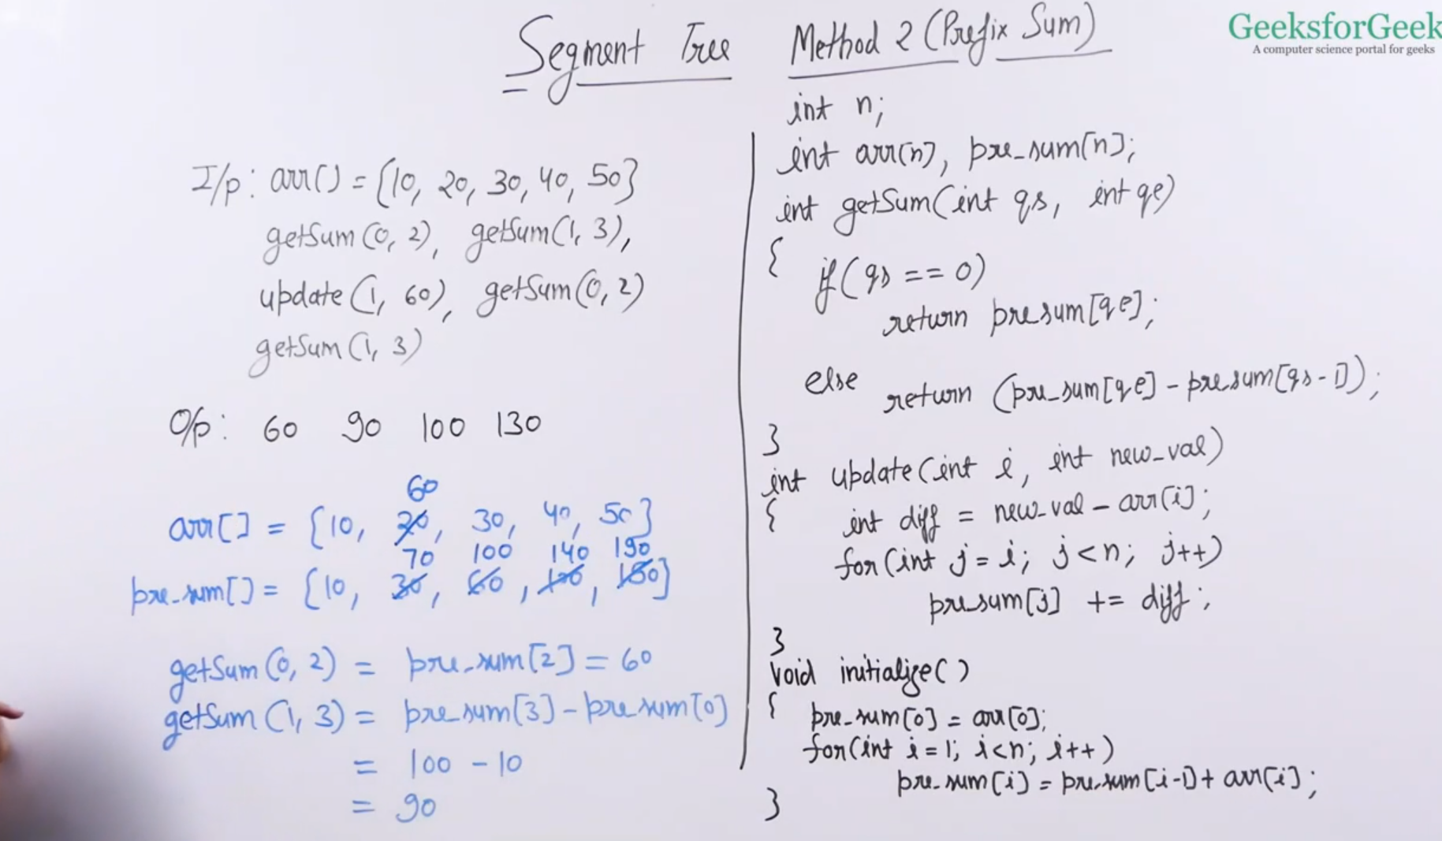

This take huge amount of time if there is anything like update it takes O(N) , but the getsum is just O(1), previous is update is O(1), getsum is O(N),

So need to come out of it. Better trade off with the above, hence w move on to the next.

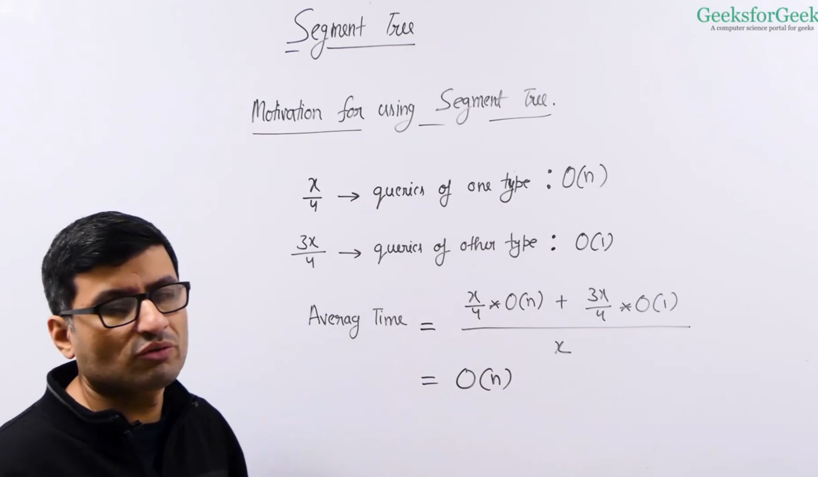

### **✅ Segment Tree — Complete Explanation with C++ Examples**

## **1. What is a Segment Tree?**

A **Segment Tree** is a **binary tree** used for efficient range queries and updates on arrays.

### **✅ Why Use It?**

Suppose you want to answer these types of queries repeatedly:

* "What is the sum of values from index l to r?"
* "What is the minimum in the range [l...r]?"
* "How many even numbers in range [l...r]?"

For large arrays and multiple queries, a **brute-force approach is too slow** (O(n) per query).

**Segment Trees reduce this to O(log n)** per query and update.

## **2. Segment Tree Basics**

* Built from an input array in O(n) time.
* Each node represents a segment (range) of the array.
* Leaf nodes represent individual elements.
* Internal nodes store combined info (like sum/min/max) of their child ranges.

### **✅ Visual Example:**

Given arr = [1, 3, 5, 7, 9, 11], a segment tree for sum would look like:

[0,5]:36

/ \

[0,2]:9 [3,5]:27

/ \ / \

[0,1]:4 [2,2]:5 [3,4]:16 [5,5]:11

/ \

[0,0]:1 [1,1]:3

## **3. Easy Problem: Range Sum Query**

Given an array, answer multiple range sum queries.

### **🧠 C++ Code:**

#include <bits/stdc++.h>

using namespace std;

class SegmentTree {

vector<int> tree;

int n;

void build(vector<int>& arr, int node, int start, int end) {

if (start == end) {

tree[node] = arr[start];

} else {

int mid = (start + end) / 2;

build(arr, 2 * node, start, mid);

build(arr, 2 * node + 1, mid + 1, end);

tree[node] = tree[2 * node] + tree[2 * node + 1];

}

}

int query(int node, int start, int end, int l, int r) {

if (r < start || end < l)

return 0;

if (l <= start && end <= r)

return tree[node];

int mid = (start + end) / 2;

int left = query(2 * node, start, mid, l, r);

int right = query(2 * node + 1, mid + 1, end, l, r);

return left + right;

}

public:

SegmentTree(vector<int>& arr) {

n = arr.size();

tree.resize(4 * n);

build(arr, 1, 0, n - 1);

}

int getSum(int l, int r) {

return query(1, 0, n - 1, l, r);

}

};

int main() {

vector<int> arr = {1, 3, 5, 7, 9, 11};

SegmentTree seg(arr);

cout << "Sum of [1, 3] = " << seg.getSum(1, 3) << endl; // Output: 15

}

## **4. Medium Problem: Point Update + Range Query**

Support:

* update(i, x): Update index i to x
* sum(l, r): Return sum from l to r

### **✅ Add this to previous class:**

void update(int node, int start, int end, int idx, int val) {

if (start == end) {

tree[node] = val;

} else {

int mid = (start + end) / 2;

if (idx <= mid)

update(2 * node, start, mid, idx, val);

else

update(2 * node + 1, mid + 1, end, idx, val);

tree[node] = tree[2 * node] + tree[2 * node + 1];

}

}

void updateIndex(int idx, int val) {

update(1, 0, n - 1, idx, val);

}

## **5. Hard Problem: Range Minimum Query + Lazy Propagation**

Support:

* updateRange(l, r, val): Add val to all elements from l to r
* queryMin(l, r): Get minimum in range [l...r]

### **✨ This needs lazy propagation (so that you don’t update all nodes every time)**

Let me know if you want full code for this advanced version — it's useful in competitive programming and system design (like memory managers, compilers, etc).

## **🔚 Summary**

|  |  |  |
| --- | --- | --- |
| **Problem Type** | **Time per Query** | **Code Complexity** |
| Range Sum | O(log n) | Easy |
| Range Sum + Point Update | O(log n) | Medium |
| Range Add + Min Query (Lazy) | O(log n) | Hard |

Would you like the **hard version with lazy propagation**, or one based on **range minimum or GCD** next?